INSTRUCTION MANUAL FOR
ONLINE REGISTRATION FORM
FOR B.Sc. Nursing, M. Sc. Nursing, Post Basic B. Sc. Nursing COURSES
FOR SESSION 2016

Website | www.pnrconline.in
Support | support@veritasinfosolutions.com
Information | info@pnrc.in
Developed by
 | Do you have any questions: +918699336655

Disclaimer: All information provided in this document is correct up to our best knowledge. This document or any part of this document can not be used as legal statement of PNRC. O/o Punjab Nurses Registration Council, Chandigarh and M/s Veritas Infosolutions, Chandigarh is not responsible for any miscommunication due to lack of expression or lack of understating or any other aspect.

1. Process Flow

Before starting Online Registration Form, please understand process flow carefully to avoid any kind of ambiguity.

 |  |  | PROCESS |  |  | ACTION TO BE
 |  |  |  |  |  | TAKEN BY
 | Step 1 |  | Student need to carry scanned copy of all required documents before |  |  | Student
 |  |  | Starting online Registration Form filling process.
 | Step 2 |  | Go to |  |  | Student
www.pnrconline.in
Click on Online Registration
 | Step 3 |  | Start filling up online Registration Form of students one by one
 |  |  |  |  |  | Student
 | Step 4 |  | You will receive a Reference application number on your registered mobile number.
 | Step 5 |  | Upload all supporting documents, photo along with |  |  | Student
 |  |  | other mandatory details of candidate
 | Step 6 |  | Upon uploading of all documents, ‘Payment Challan’ will be available for printing |  |  | Student
 | Step 7 |  | Student need to carry the Challan to nearest HDFC |  |  | Student at HDFC
 |  |  | branch for payment of ‘Online Registration Fees’ |  |  | Bank Branch

- General Instructions

  - Candidates are expected to ensure eligibility criteria before starting Online Registration Form Process.

  - Any attempt of registration for ineligible candidates will be discarded by software. In exceptional case if accepted by software then online registration form will be discarded by council and no admission fee will be refunded.

  - Before starting online registration form filling process, candidates to make following documents available in form of soft copy.
- 10th Certificate
- 12th Certificate
- DMC (1st Year)
- DMC (2nd Year)
- DMC (3rd Year)
- DMC (4th Year)
- Photo ID Proof/Affidavit (Aadhar Card, Driving License, PAN Card, Voter Card, Passport, Any Other Government Issued Document with Photo)
- Training completion certificate issued by school/college and photo attested by principal.
Note:-
If applicant name and father's name does not match with any of above mentioned list of documents or applicant does not have any valid Photo ID Proof then applicant need to submit a 'Personal Identification Affidavit' attested by an authorized notary at the time of registration.

  - This application is most compatible with latest version of Google chrome and minimum compatible screen resolutions is 1280X720.

3. How to start Online Registration Form Process?

IMPORTANT NOTE: Please read all instructions carefully for Online Registration Form.

A. For Online Registration Form Process, go to online portal - http://www.pnrconline.in

B. Go to “Online Registration” over the menu bar.
C. Roll mouse cursor over “Online Registration” menu and go to “Registration Form” from the drop down menu. Then click on “Registration Form” menu.

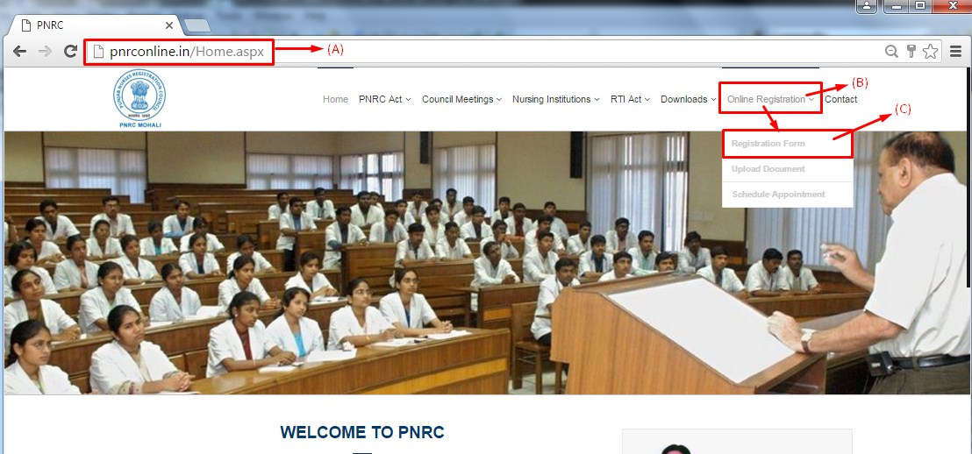

D. Fill up all fields carefully. Candidate need to fill up all details in respective text boxes.

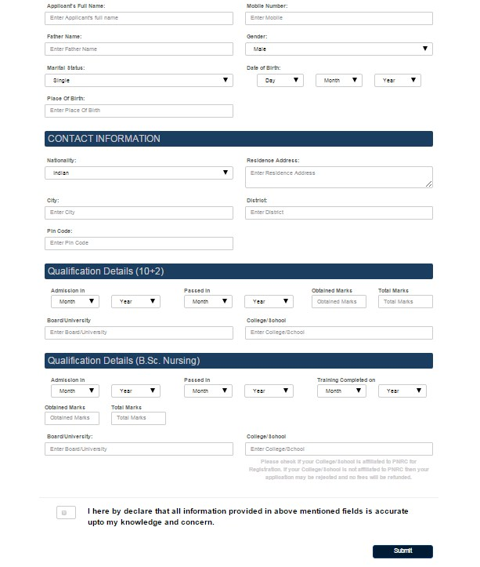

Note:-
Mobile number must be filled 10 digit format only eg.– 9876543210.

- Contact Information – The following segment need to be filled with contact details of candidate like Nationality, City, Pin Code, Residence Address, District etc. All fields are mandatory.

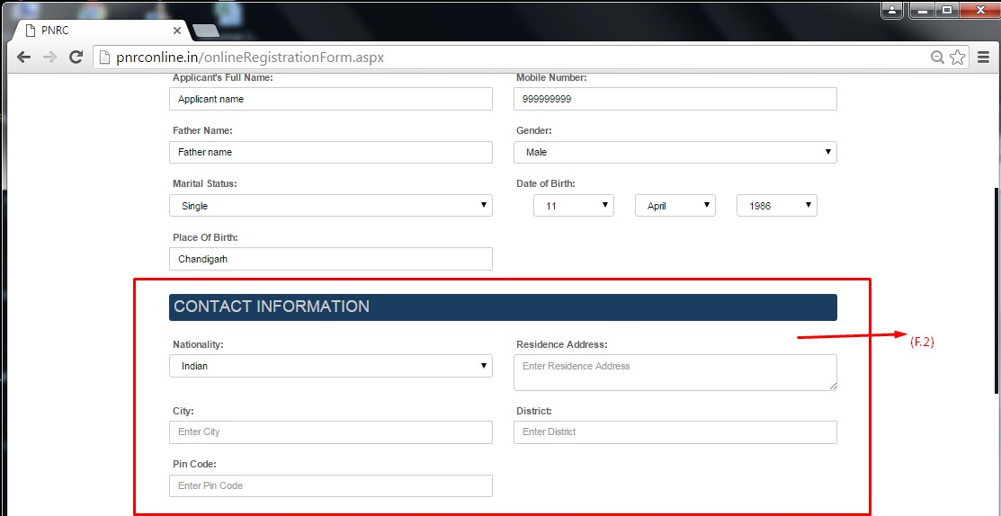

Please check if your College/School is affiliated to PNRC for Registration. If your College/School is not affiliated to PNRC then your application may be rejected and no fees will be refunded.

- Qualification Details - This segment need to be filled with qualification details of candidate. All fields are mandatory.

- If Candidate is registering for B.Sc. Nursing, he or she need to be filled the following details like Admission Date of 12th, Passed Out Date of 12th, Board/University Name, College/School name of 12th, Obtained Marks in 12th, Total Marks of 12th etc.

B.Sc. Nursing details as follows – Admission year with month in B.Sc. Nursing, Passing Year of B.Sc. Nursing, Obtained Marks, Total Marks, Board/University, School/College Name etc.

Note: - If Candidate select passing year less than 2015 like 2014, 2013 or less from the Qualification Details of B.Sc. Nursing section, candidate need to enter his or her gap reason as follows below.

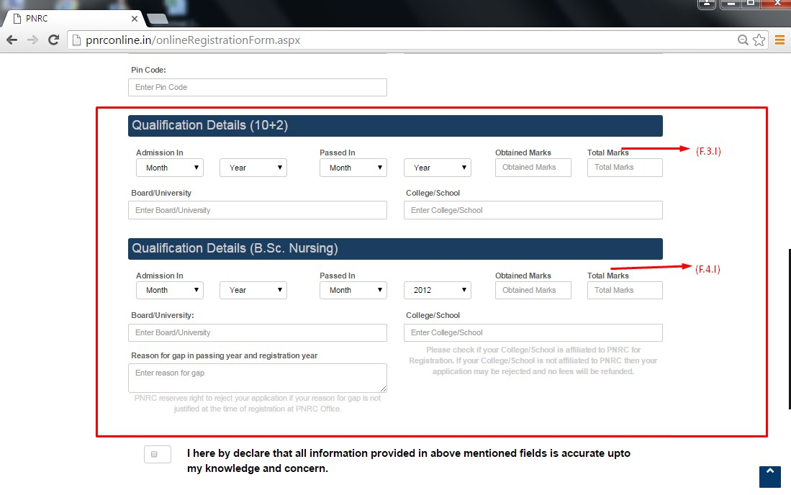

- If Candidate is registering for M.Sc. Nursing, he or she need to fill up his or her B.Sc. Nursing Qualification details like Admission year with month in B.Sc. Nursing, Passing Year of B.Sc. Nursing, Obtained Marks, Total Marks, Board/University, School/College Name, Date of Registration, B.Sc. Nursing Registration Number etc.

M.Sc. Nursing details like Admission year with month in M.Sc. Nursing, Passing Year of M.Sc. Nursing, Obtained Marks, Total Marks, Board/University, School/College Name etc.

Note: - If Candidate select passing year less than 2015 like 2014, 2013 or less from the Qualification Details of M.Sc. Nursing section, candidate need to enter his or her gap reason as follows below.

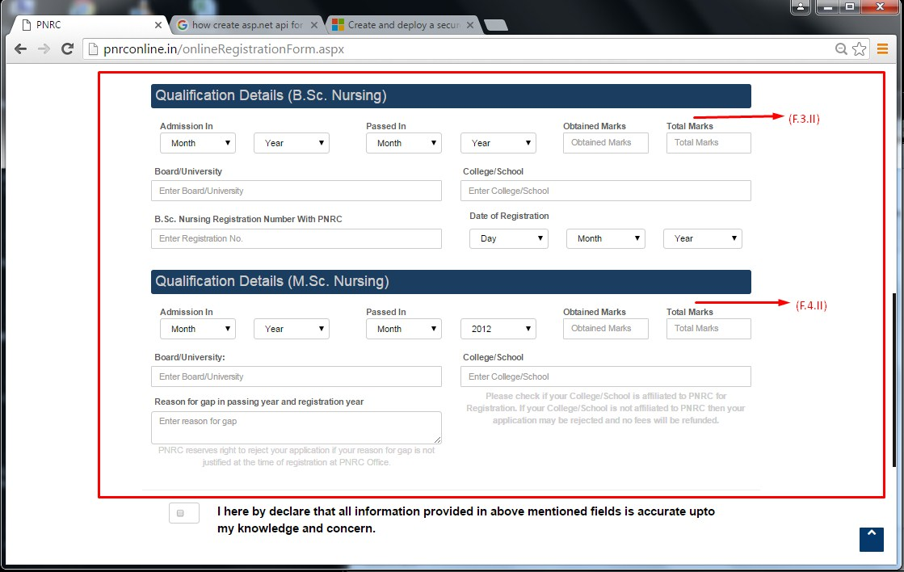

- If Candidate is registering for Post Basic B.Sc. Nursing, he or she need to fill his or her qualification details of GNM like Admission year with month in GNM, Passing Year of GNM, Obtained Marks, Total Marks, Board/University, School/College Name, Date of Registration, GNM Registration Number etc.

Post Basic B.Sc. Nursing details like Admission year with month in Post Basic B.Sc. Nursing, Passing Year of Post Basic B.Sc. Nursing, Obtained Marks, Total Marks, Board/University, School/College Name etc.

Note: - If Candidate select passing year less than 2015 like 2014, 2013 or less from the Qualification Details of Post Basic B.Sc. Nursing section, candidate need to enter his or her gap reason as follows below.

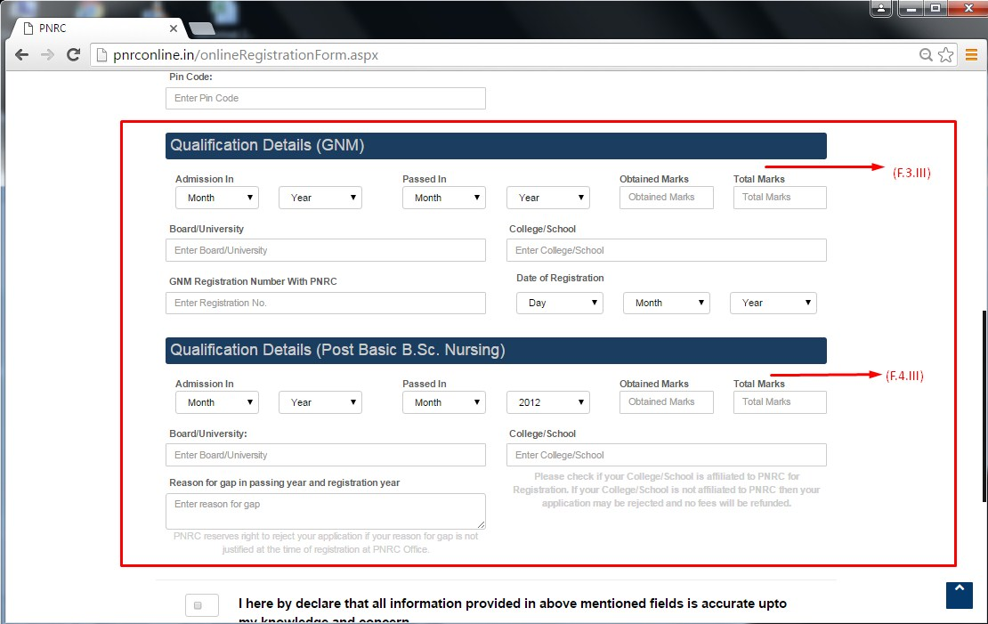

- After successfully filling up the Online Registration Form, Candidates need to accept self declaration first and click on the Submit button for successfull registration.

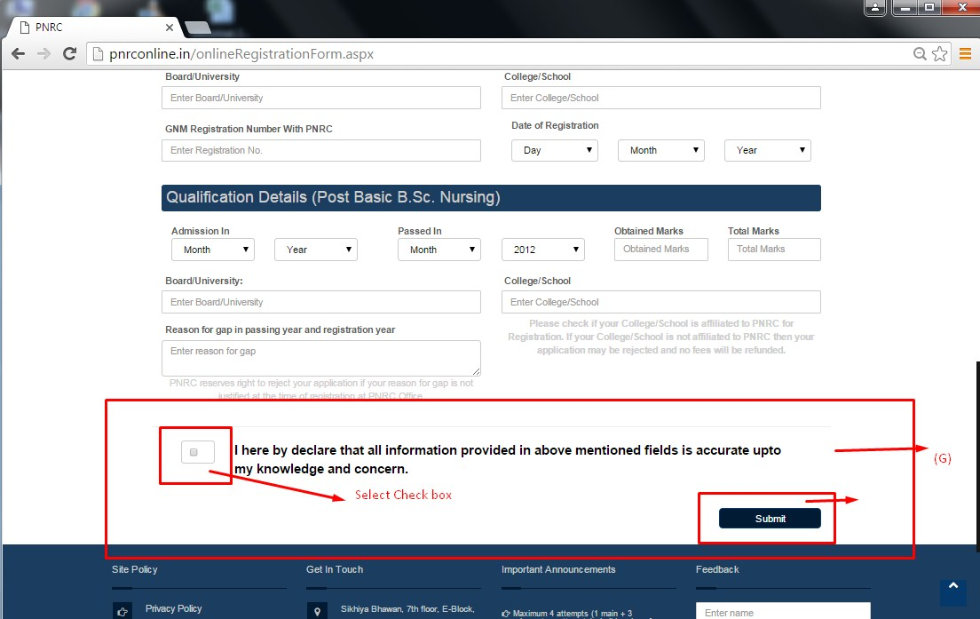

- After Click on the Submit button, candidate will be automatically redirected to STUDENT DETAIL AND UPLOD DOCUMENTS PAGE.
- Please enter unique Application Reference Number received on your registered mobile number via SMS. Please wait for up to 15 minutes.

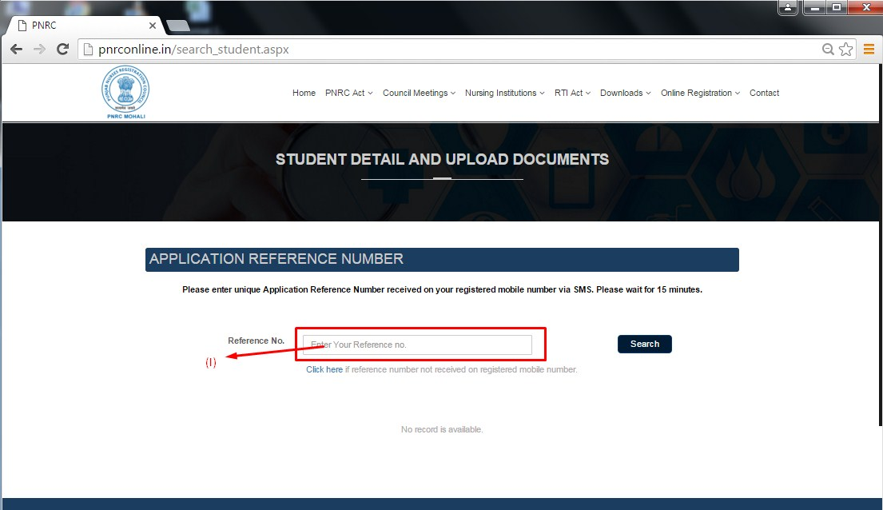

In any case, candidates have not received their reference number, he or she will do the following task.

- Candidate need to click on the Click Here button.
- Enter their registered mobile number to get reference number again.

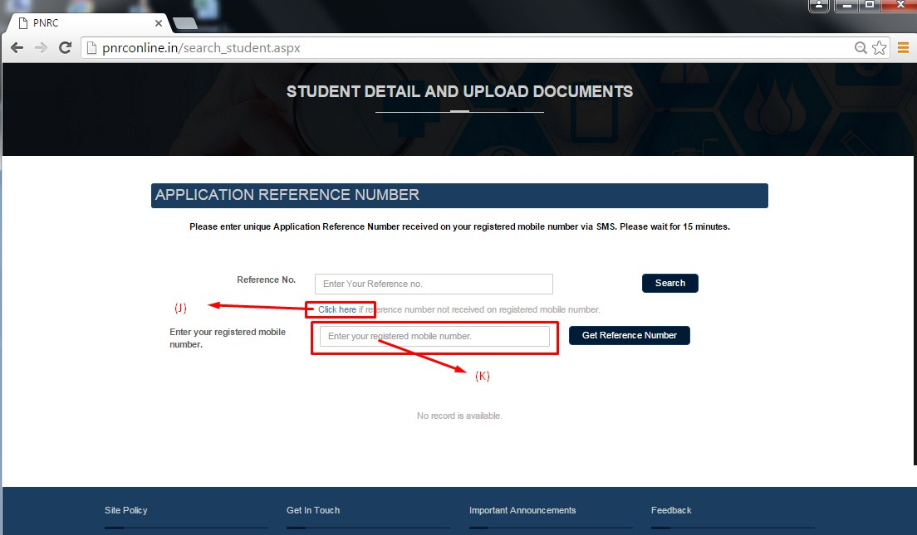

- After entering reference number successfully, candidates will see his/her own details.

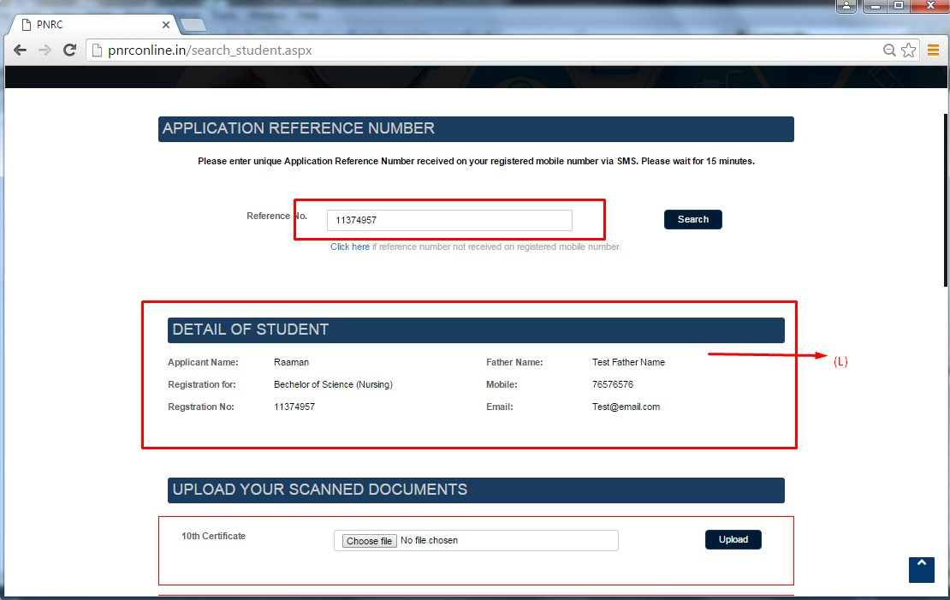

After checking details, Candidates need to upload their scanned documents as follows below:-

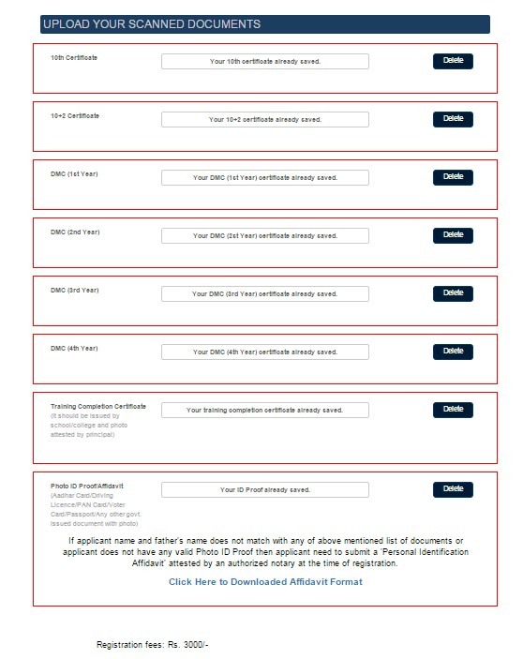

- Uploading scanned documents successfully, Candidates need to upload their Id proof.
- Candidate shown Registration fee below according their selected registration courses. Registration fee for M.Sc. Nursing will be Rs. 3000 and for B.Sc. Nursing, Post Basic B.Sc. Nursing will be Rs. 2000.

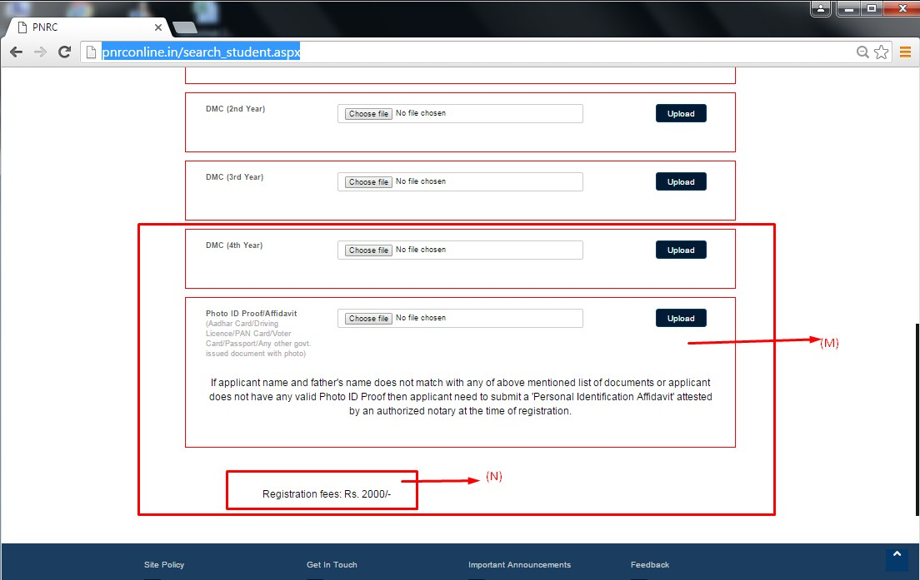

- After uploading all scanned documents carefully, candidates need to click on the Print Challan button as follows -

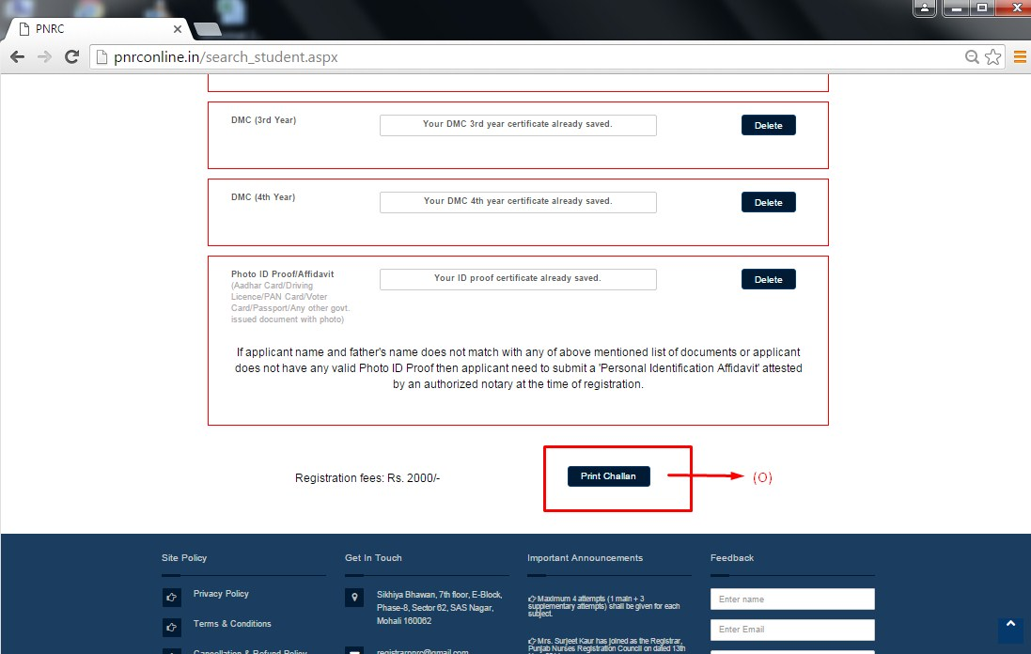

- Print Challan Form as follows -

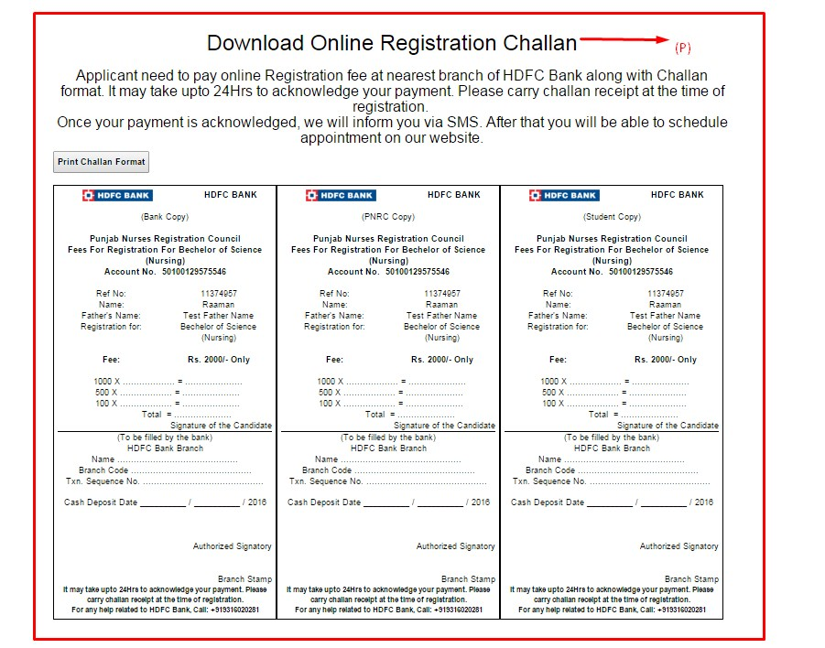

After submitting Challan form at any branch of HDFC Bank, Candidates get confirmation for successfully Online Registration through SMS on their registered mobile number within 24 hours.

- After getting Online Registration confirmation, Candidates can Scheduled their Appointment as follows -

- Candidate need to visit Online Registration Portal here – http://pnrconline.in
- Find “Online Registration” over the menu bar.
- Roll mouse cursor over “Online Registration” menu and find “Schdule Appointment” from the drop down menu. Then click on “Schdule Appointment” menu as follows below –

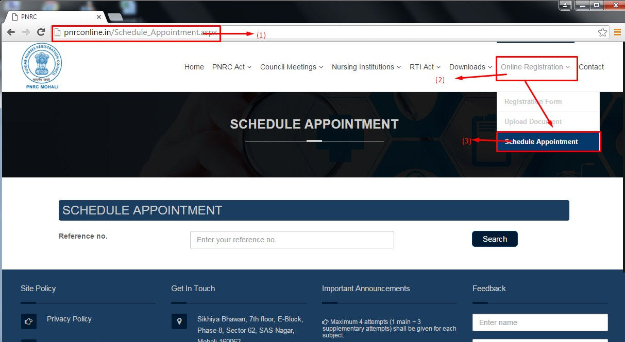

- After visiting “Schdule Appointment” Page, Candidate need to fill their reference number and click on the Search button for further process as follows –

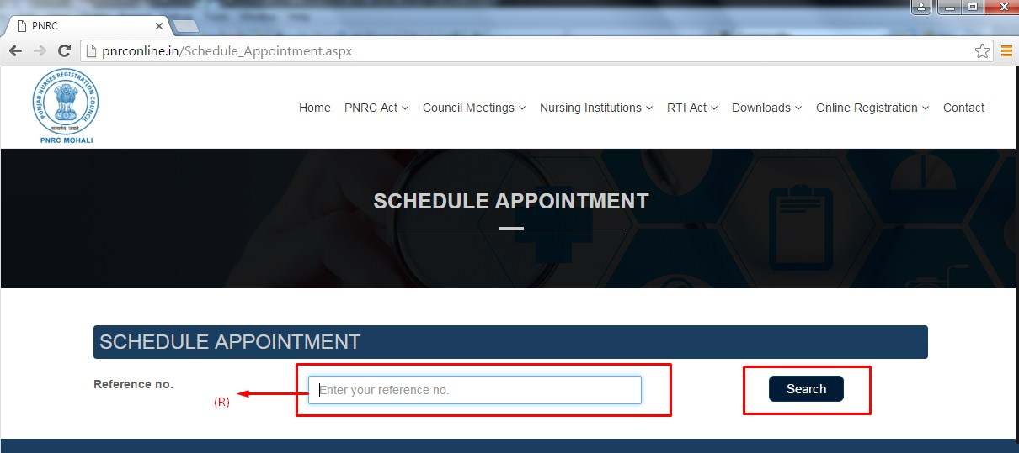

- After entering reference number and matching candidate data successfully, Candidate need to select appointment date and Schdule Appointment successfully.
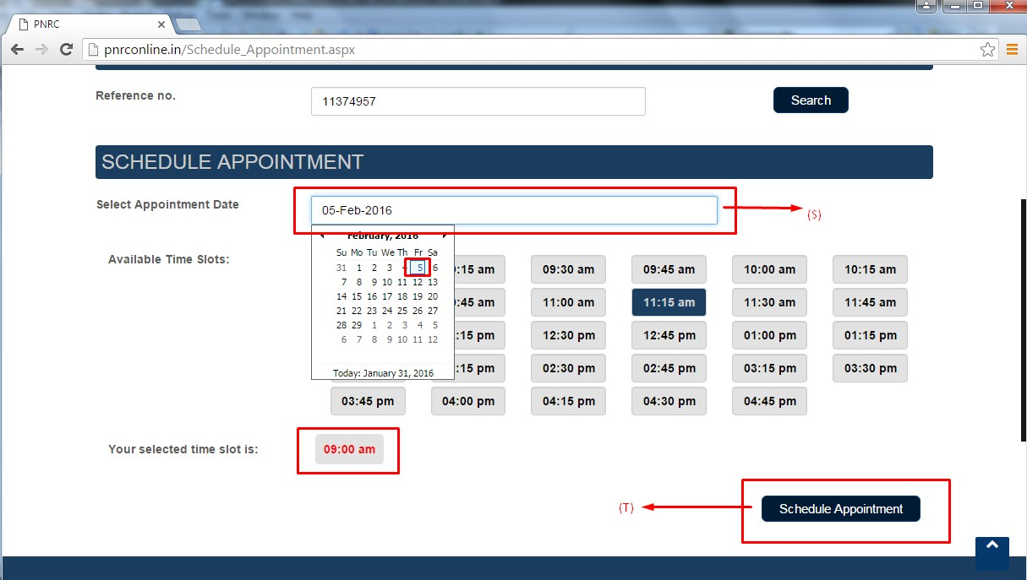
Note:-
Appointment date should not be altered after fixing appointment once.

After successfully scheduling appointment, candidates need to visit PNRC along with their all original certificates/documents (Hard Copy) on the particular date which he or she has scheduled. All documents details are follows:-

- 10th certificate.
- 10+2 certificate.
- DMC (1st year).
- DMC (2nd year).
- DMC (3rd year).
- DMC (4th year).
- Photo ID Proof/Affidavit.
- Training competition certificate issued by school/college and photo attested by principal.
- Student challan copy.

