User Manual
For
Online Consent Management & Monitoring System

Presented To:
Ministry of Environment & Forest



Index

1. Introduction ………………………………………………………. 02
2. Online Industry Registration ……………………………………... 04
3. Login Process …………………………………………………….. 07
4. Features of Industry User ………………………………………… 12
5. Consent Management …………………………………………….. 13

INTRODUCTION
Online Consent Management & Monitoring System is a web based application for Consent Management developed for the SPCB (State Pollution Control Board), Ministry of Environment & Forest.

Application is divided in to the two parts as given below.
- BSPCB User
- Industry User

Consent Management includes:
- Issue of “Consents to Establish” and “Consents to Operate” in respects of industries, mining projects etc.
- Assessment and monitoring the quality of water, ambient air and stack emissions
- Inspection of sites proposed for setting up of industries to verify the suitability of the same from environmental point of view
- Ambient air quality monitoring under National Air Monitoring Program (NAMP)
- Offering guidance to industries and local bodies on statutory provisions
- Inspection of industries for effective monitoring and evaluation

Features of OCMMS
- Unified Global online application/ portal
- Role based application access
- Multi level Security Enabled System
- Online Industry Registration
- Online Submission of Application, Approval, Clarification and other activities for CFE, CFO for all category of Industries/Institutions
- Consent Management
- Laboratory Management
- Waste Management
- Reports

Online Industry Registration

Industry registration is an online feature; which will enable Industry applicant to register himself online to use the application for applying for Consents (CTE/CTO), Authorization and other features. Using this Industry will be able to generate the temporary user name and password; which he needs to use within the stipulated time. Once Industry uses the temporary user name and password for Consent Application; documents/details provided with this will be validated and user name will be confirmed and made available to him for future use.
If Industry fails to use the temporary user name within the given time frame, then this user name will be deleted from the database and applicant will have to re-register himself to use the online application.

Steps to use this feature:
- User opens the URL in browser.
- Click “New Registration”
- New Registration form will be displayed.
- User fills the asked information and click “Submit”.
- Once submitted, System will validate the input data.
- If data is incorrect or mandatory filled not filled then system will prompt user to correct the information.
- If data filled by applicant is correct then System will generate Temporary user name and password and will be displayed on screen.
- Process of N
- New Industry Registration is given below.

- Open Home Page by entering URL in Browser.

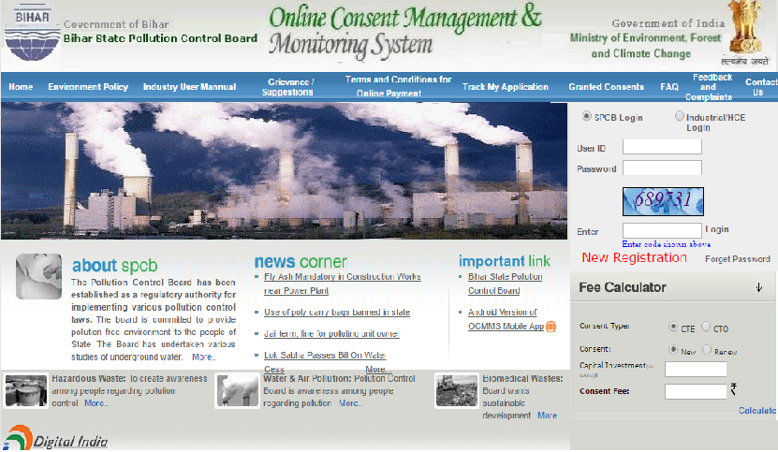
Click on New Industry Registration to register Industry
Screen Shot: Home Page

- Click on New Industry Registration link on Home Page.

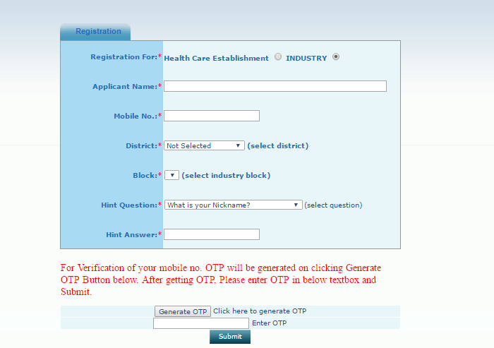

Screen Shot: Industry Registration Window

- After filling the mandatory Industry Details, Generate OTP and then fill the OTP and save it.
- It gives User ID and Temporary Password.

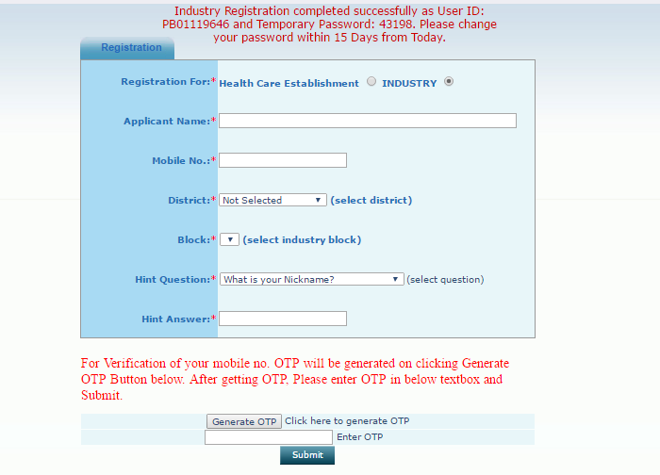
Screen Shot: Industry Registration Window

Profile Details

When you are login as Industry User with this User ID and Password, firstly user have to fill the Profile Details
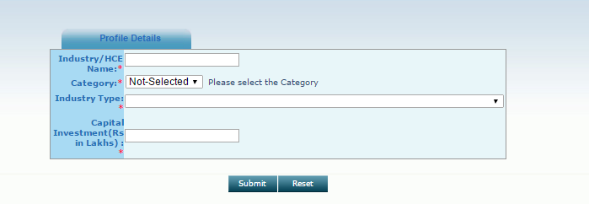

- Features of Industry User:

After Login, Industry User home page is given below.

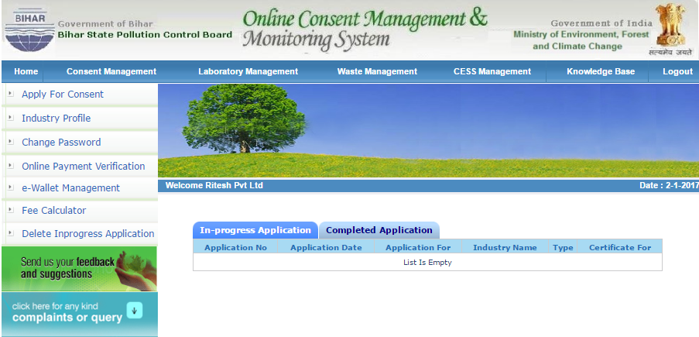

Screen Shot: Industry User Home Window

Modules for Industry User
- Consent Management
- Apply For Consent
- Industry Profile
- Change Password
- Delete Application
- Consent Fee Calculator
- Online Payment Verification
- E-wallet management
- Consent Management

Click on Apply For Consent.

Screen Shot: Consent Management Window

After clicking on Apply for Consent Below window will appear.

  - Apply For Consent

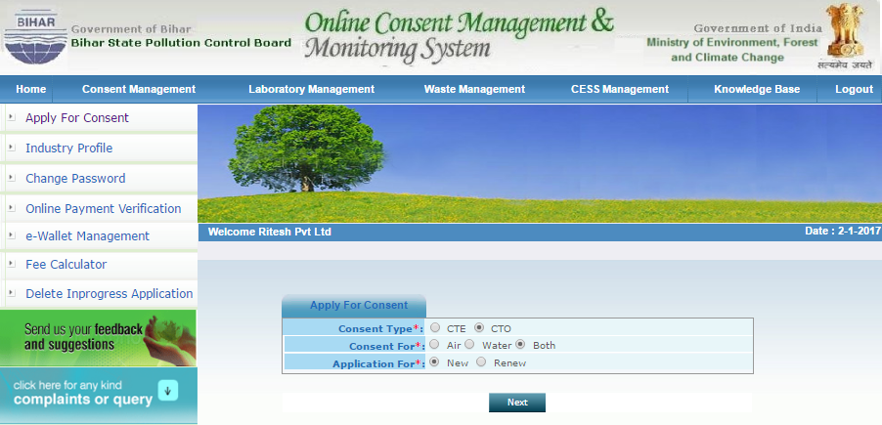
Select Consent Type
Select Consent For
Click on Next

Screen Shot: Apply for Consent

After consent application below window will appear.

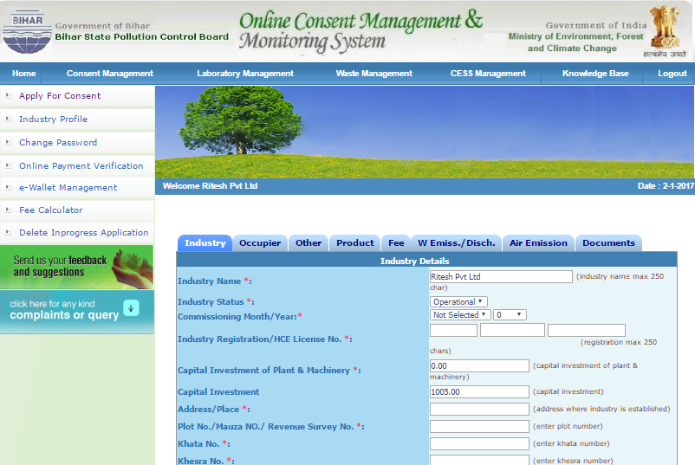
Click on the below Menu & Enter the Details

Screen Shot: Consent Application Window

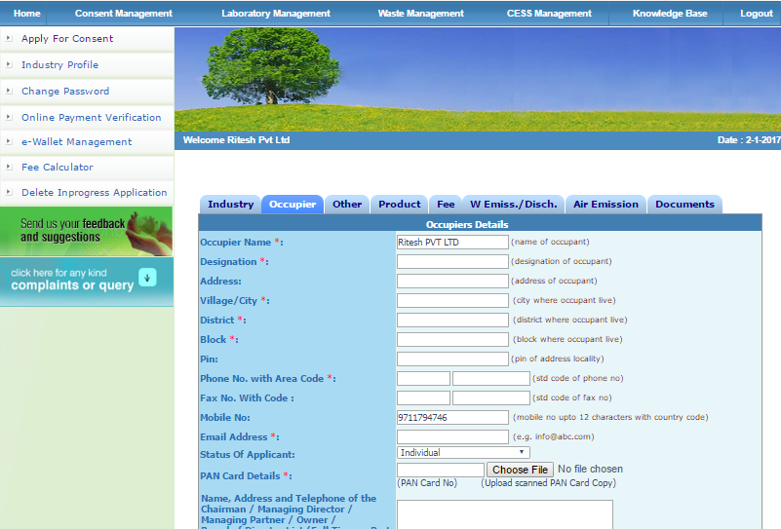
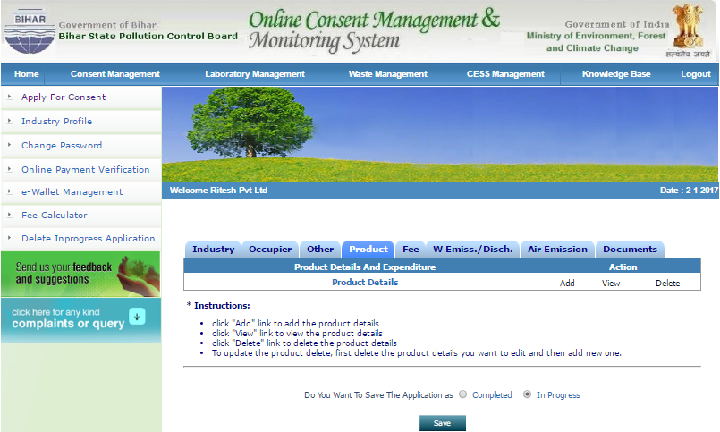

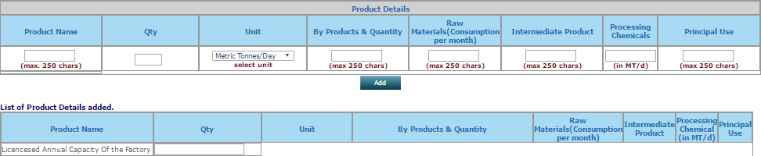

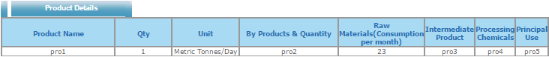

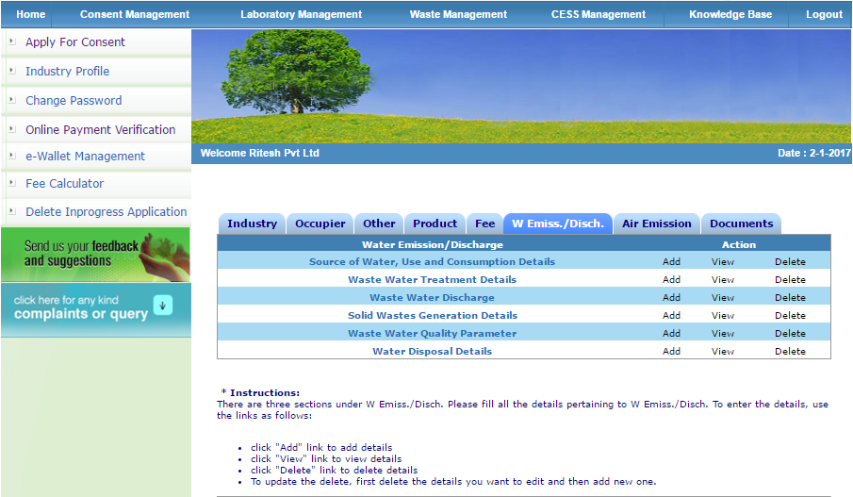

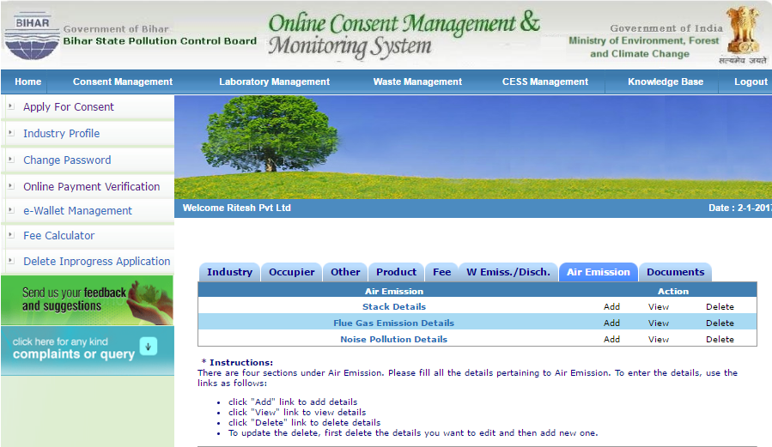

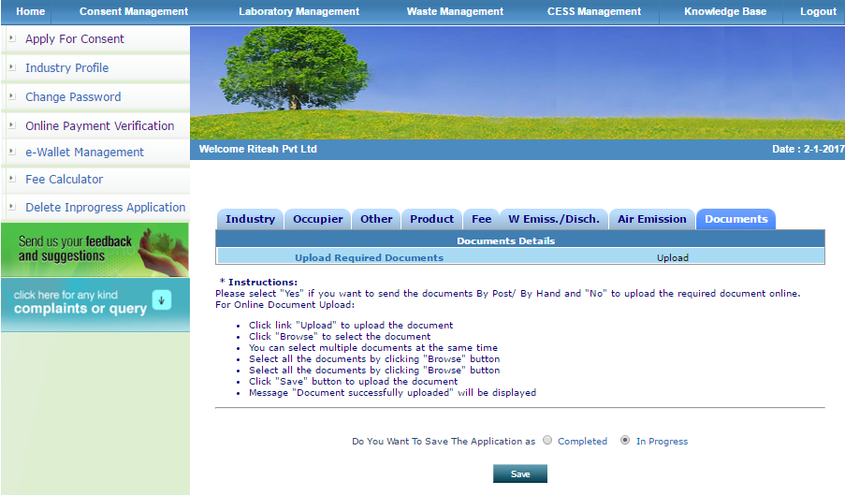

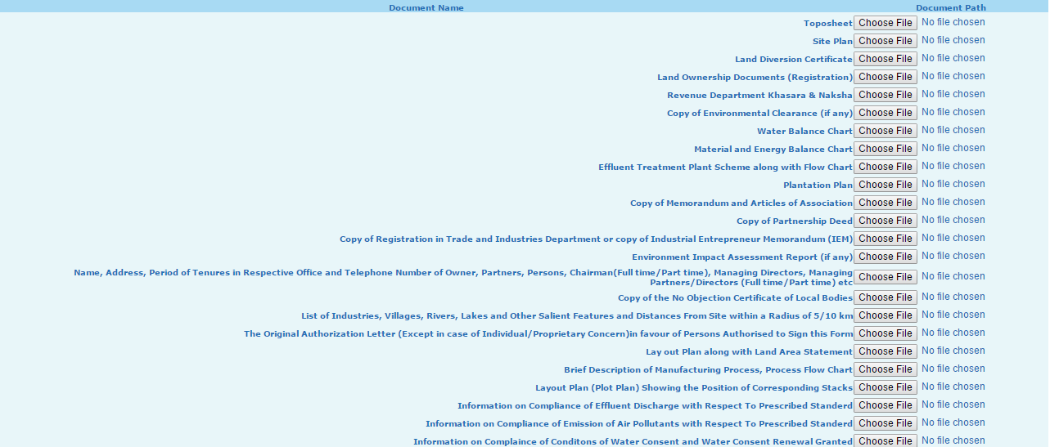

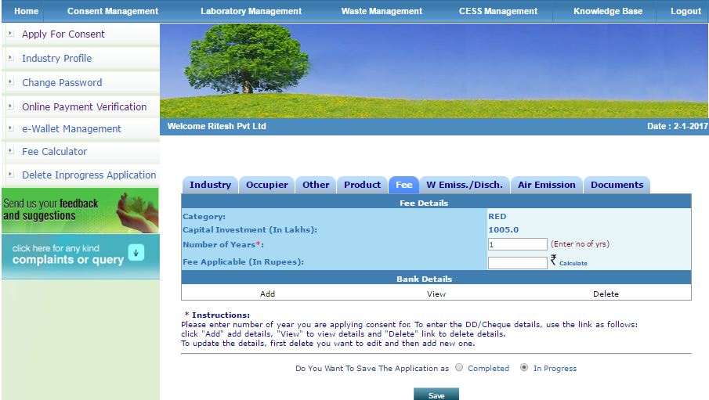

Select Completed and Click Save Button

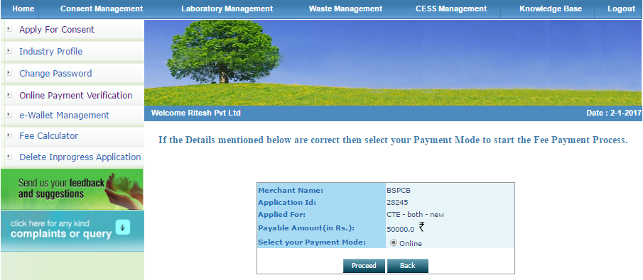

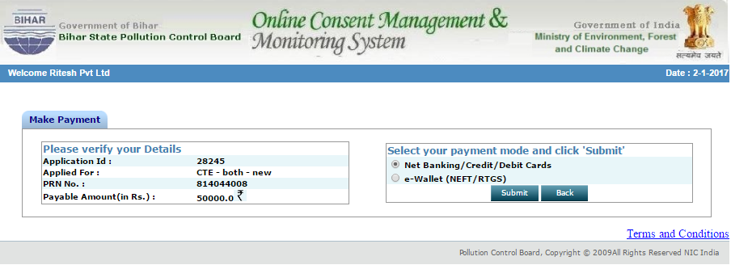

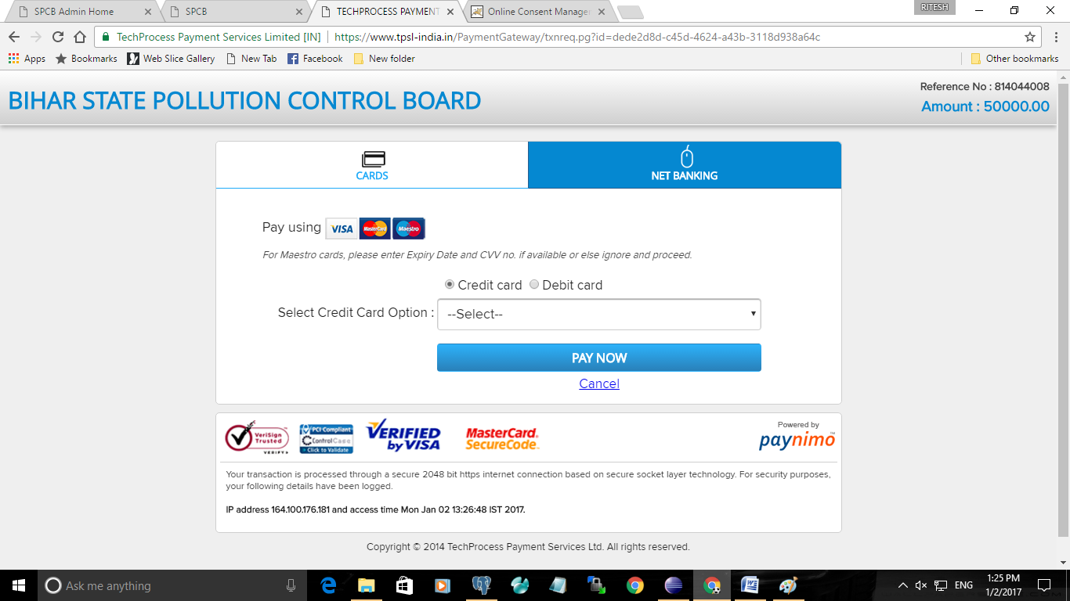

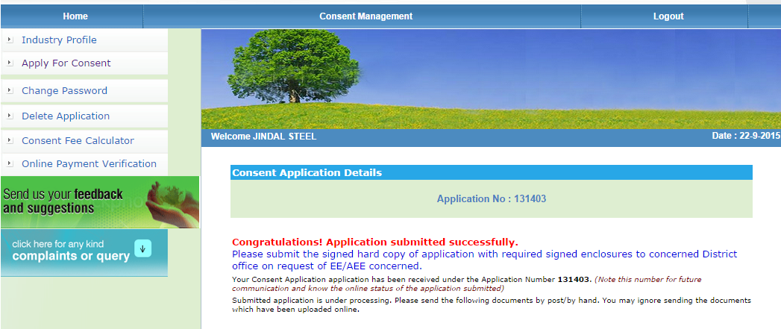

Thank You!

