Government of Madhya Pradesh

Madhya Pradesh VAT Portal

User Manual – e-Registration - VAT

Release 1.0

August, 2010

Government of Madhya Pradesh

Madhya Pradesh VAT Portal

User Manual – e-Registration - VAT
Version 1.0

August, 2010

Tata Consultancy Services Ltd
Info Tower I, Info city,
Airport Road
Gandhinagar-382009, Gujarat.

Notice
This is a controlled document. Unauthorized access, copying, replication or usage for a purpose other than for which it is intended, are prohibited.
All trademarks that appear in the document have been used for identification purposes only and belong to their respective companies.

PF3020
Document Release Note

Notice No.:
Customer: Commercial Taxes Department, Government of Madhya Pradesh
Project: MPVATIS

Document details
Name | Version no. | Description
TCS-MPVAT-UM-e-Registration-VAT | Version 1.0 | The document is being prepared to assist the user to perform the process through the MPCTD Web-Portal of MPVATIS project. The document is prepared with the help of current version of application (Web-Portal module) and subject to minor/major change(s) due to the modification(s) in web portal, as and when applicable.

Revision details
Action taken  (add/del/change) | Previous  page no. | New page no. | Revision description

Change Register serial numbers covered:
The documents or revised pages are subject to document control.
Please keep them up-to-date using the release notices from the distributor of the document.
These are confidential documents. Unauthorized access or copying is prohibited.

Approved by: Authorized by:

Date: Date:

PF2060C
Document Revision List

Customer: Commercial Taxes Department, Government of Madhya Pradesh
Project: MPVATIS
Document Name: TCS-MPVAT-UM-e-Registration-VAT

Release Notice Reference (for release)
Rev. No. | Revision date | Revision description | Page no. | Previous page no. | Action taken | Addenda/New page | Release notice reference

About this Manual

Purpose
The purpose of this document is to describe the e-Registration functionality in MPVAT Portal for VAT Dealer.

Intended Audience
This document is intended for the dealers in Madhya Pradesh.

Organisation of the Manual
Information in this manual has been organised as follows:
Table 1 : Organisation of Manual

Chapter | Description
Chapter 1 | It provides brief introduction of Web Portal.
Chapter 2 | It provides brief overview of VAT e-Registration module
Chapter 3 | Describes the VAT e-Registration functionality.

Contents
1 Introduction to Web Portal 10
2 Introduction to e-Registration 11
3 Operational Instructions 12
3.1 E-Registration 12
3.1.1 Download registrations form (.xls) 12
3.1.2 Filling the template/form for the Registration 14
3.1.3 Upload and Submit the form 16
3.2 Track Your Status 24
List of Tables

Table 1 : Organisation of Manual 5
Table 2 : Abbreviations 9
List of Figures

Figure 1 : Home Page 12
Figure 2 : Download Forms and Files 13
Figure 3 : Excel Sheet for VAT e-Registration Form 15
Figure 4 : VAT e-Registration Form 16
Figure 4 : VAT e-Registration Form 16
Figure 5 : Entering details for e-Registration Form for VAT Dealer 17
Figure 6 : Data Validation 18
Figure 7 : Showing error message in data entry 19
Figure 8 : No error found screen 20
Figure 9 : Acknowledgement Receipt 22
Figure 10 : E-mail received on upload of TIN registration form 23
Figure 11 : Track Your Status link in Home Page 24
Figure 12 : Track Your Status screen 25
Figure 13 : Track your status screen with data entered 26
Figure 14 : Track Your Status Result after entering Search Code 27
Figure 15 : Detailed Form. 30

List of Abbreviations

Table 2 : Abbreviations

Abbreviation/ Acronym | Description
CTD | Commercial Taxes Department
FAQ | Frequently Asked Question
RSS | Really Simple Syndication
TIN | Dealer Identification Number
URL | Uniform Resource Locator
UM | User Manual
VAT | Value Added Tax

- Introduction to Web Portal
The government of Madhya Pradesh has launched a web portal with URL https://www.mptax.mp.gov.in .The web portal offers different kind of information on Domestic Taxes in Madhya Pradesh.
The portal offers major functionalities like :
- E-services like e-registration, e-returns, e-amendment, e-communication and e-payment
- News, updates, circulars and notifications
- ‘Search the website’ functionality
- Tracking the status of various applications on-line
- Using virtual keyboard for entering password
- FAQs, Query posting and replying
- Subscribe/view RSS feeds

- Introduction to e-Registration

Since e-registration is a new concept, this booklet has been prepared with a view to provide step-by-step guidance to the dealers in filing e-registration. This booklet contains details and screen shots for filing the e-registration in form. Filling of e-registration will save time for the dealer.
E-registration can be of VAT,CST,PT or LT. User can get a dealer Identification Number i.e. TIN online using this functionality. The process for e-registration is described below.

The process for the registration of dealer involves the following:

- Download Registration Form/s
- Filling data in form/s
- Uploading the filled form/s
- Obtaining the Acknowledgement Receipt
- Tracking the application status
- Operational Instructions
  - E-Registration
Process to file e-registration is very simple. A computer with internet connectivity is required for the purpose. There are four easy steps to do e-Registration. These steps are:
    - Download registrations form (.xls)
To download registration forms, connect to Internet and write URL in the address bar as under: https://www.mptax.mp.gov.in
Once the web portal is connected, the Home page will appear as shown below.

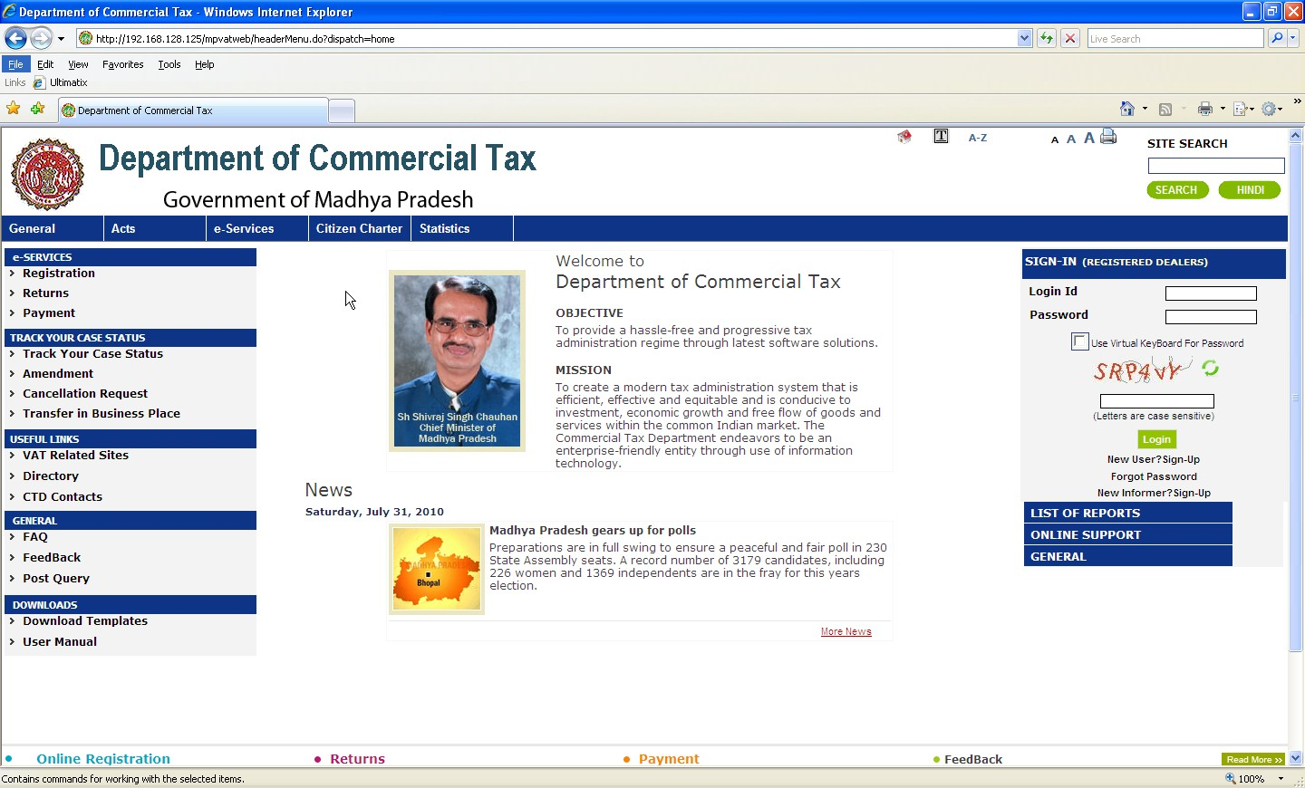
Figure 1 : Home Page

To apply for registration, dealer has to download the template from the Portal. It is advisable to download the template once and store for future use. Dealer will have to download all the templates required for Registration. For example, VAT,CST,PT and LT as applicable
In portal, Left side menu contains the link Download for downloading the blank templates (forms in form of .xls sheet). On clicking this link, it will display the screen for downloading templates for Registration as shown below. Click on appropriate link for download registration form.
Otherwise directly click on e-Registration. Here also links for downloading templates are available

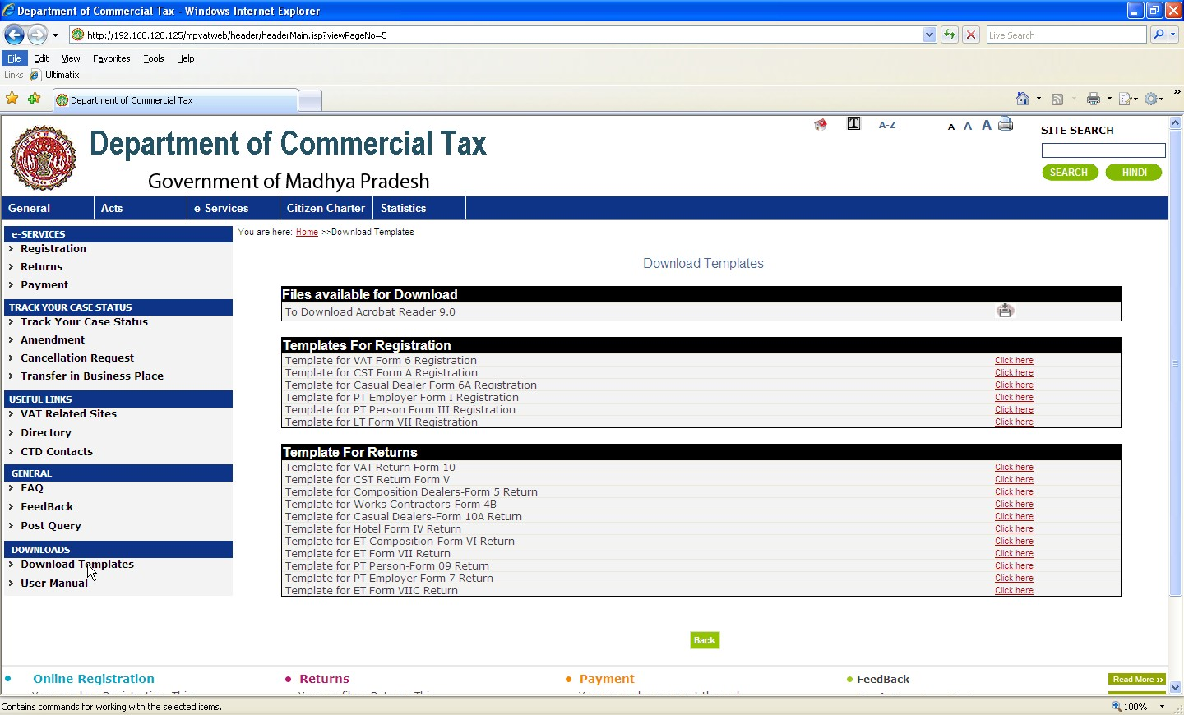
Download Template for VAT Registration
Figure 2 : Download Forms and Files

3.1.2 Filling the template/form for the Registration

(Note: Please enable Macros in MS Excel as the sheet contains macros for various validations of data.)

Before starting the Registration process dealer will have to fill all the applicable details for which he wants to register.
You should have Microsoft Excel (version may be 97, 2000, 2003 or 2007) installed in your computer for this purpose.
After downloading requisite template, data can be entered in this template.

1). Open using Microsoft Excel and fill the required details.

2). after filling the sheet click on Validate button to validate the sheet.

3). If all the data is correct then it will prompt for generating the upload file.

4). The Upload file is saved in My Documents by default.

The template for VAT e-Registration form looks like this:

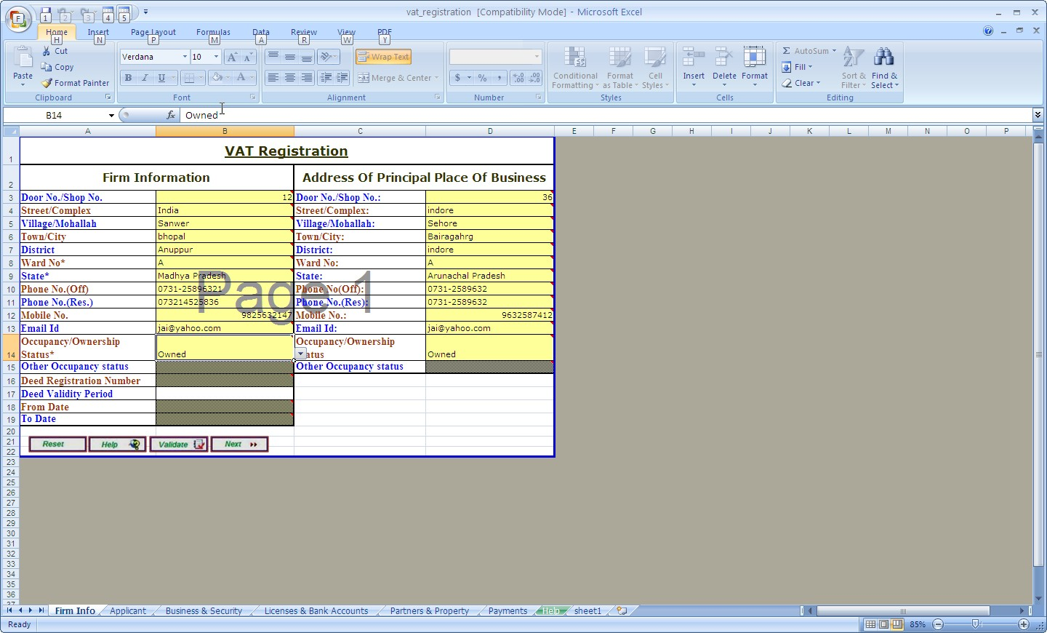
Figure 3 : Excel Sheet for VAT e-Registration Form

    - Upload and Submit the form

E-registration link is available on left side menu of VAT portal under e-Services tab. Select option for VAT e-Registration.

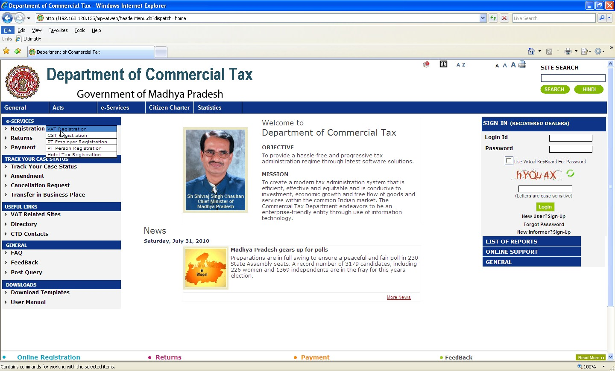
Click Here
Figure 4 : VAT e-Registration Form

Provide all the required input and upload the Generated file.

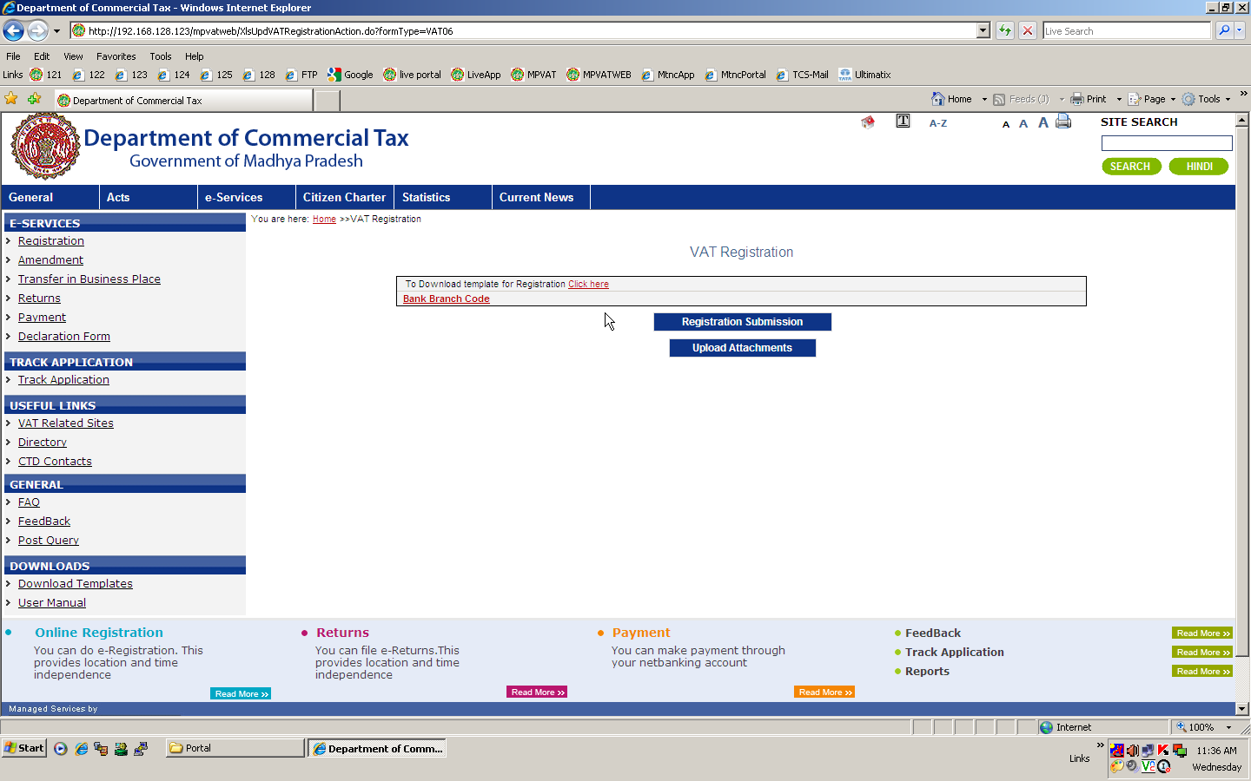

Figure 5 : Entering details for e-Registration Form for VAT Dealer

Now details filled by user will be verified by the system and if they are found correct, system will give no error message otherwise list of error messages are displayed.
On uploading the template, it will show you various statuses.
1) Uploading the file
2) Validating the data

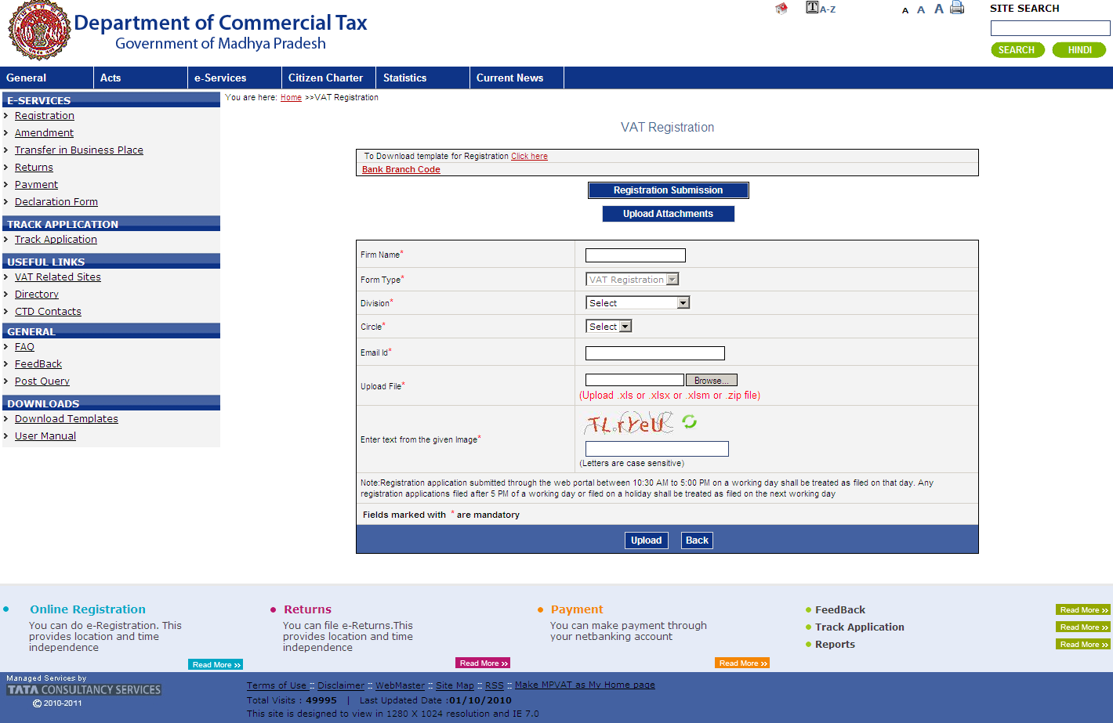

Figure 6 : Data Validation

After validation if there is some error in data entry, then it will show the error list showing the error message with the row number and sheet details. You need to correct the data and upload the templates again.

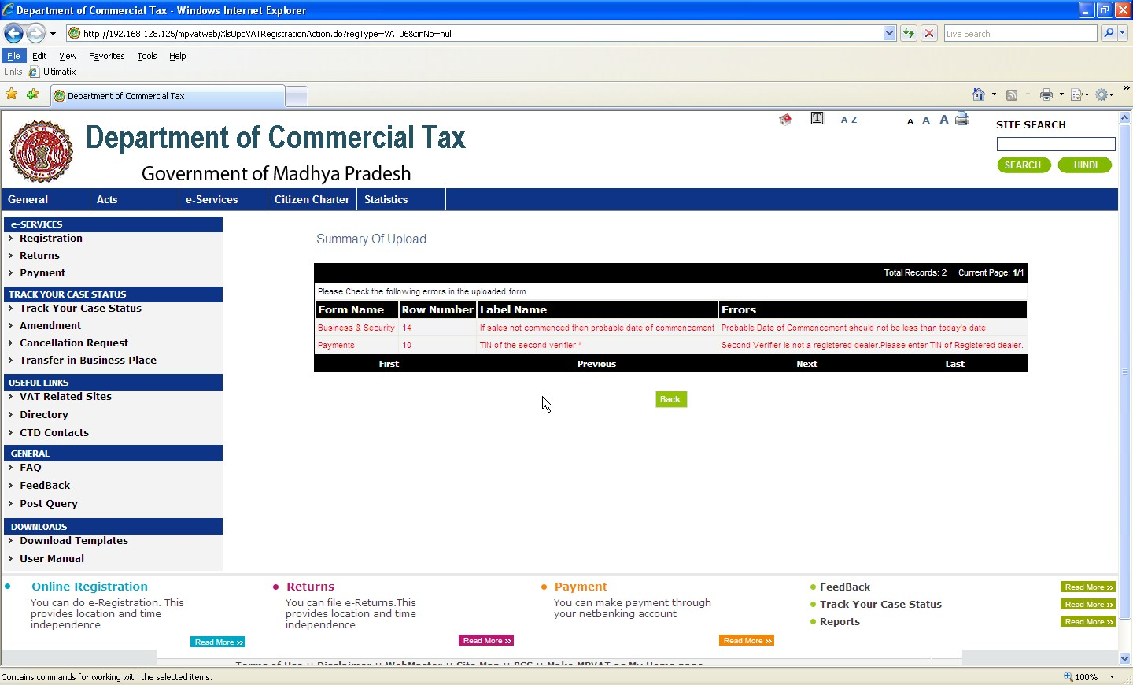
Figure 7 : Showing error message in data entry

The system will not allow submission/upload of registration sheet till the errors are corrected and a back button is provided to go back and restart the process.
If no errors are found, following screen will be displayed . Click on submit button to upload the sheet.After the sheet is uploaded successfully, a transaction id will be generated.

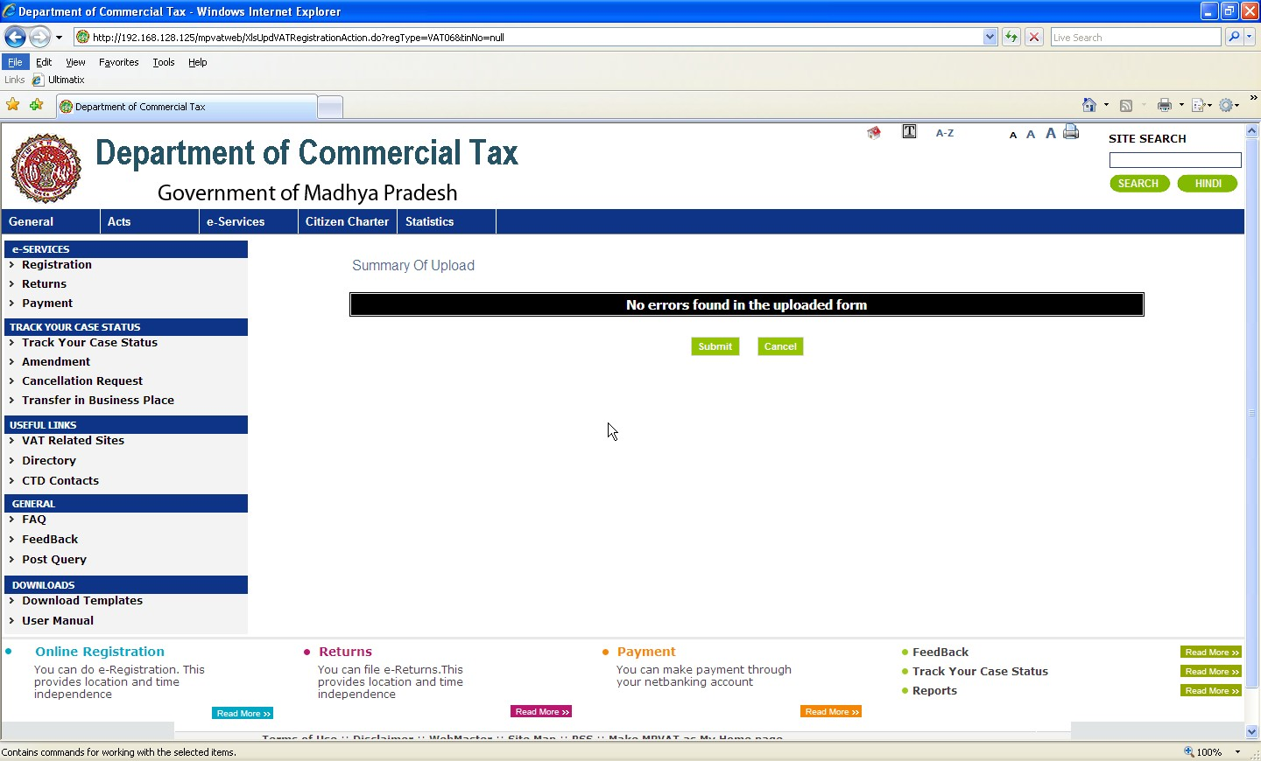
Figure 8 : No error found screen

3.1.4 After Registration Submission generate transation id.
On successful submission of form a transation id is generated for Upload attachment.

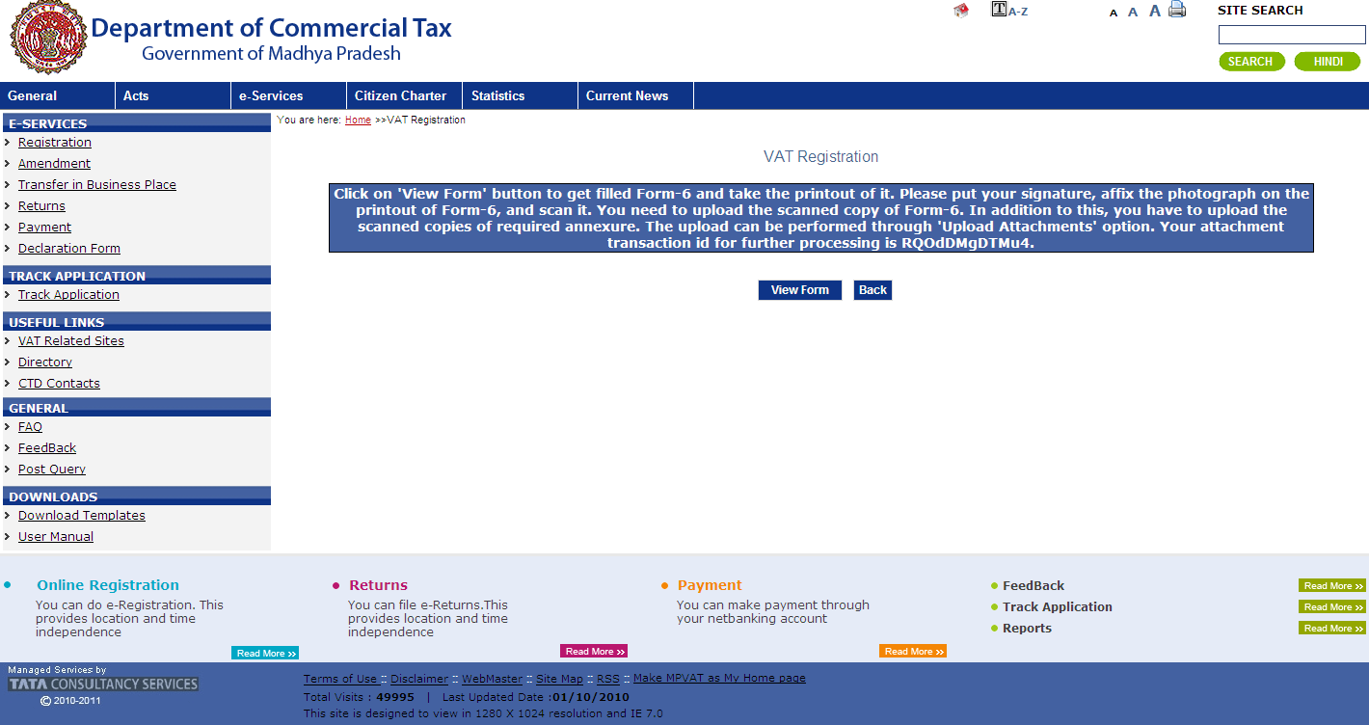
Figure: 9 Transaction ids Screen

User can view form6 on click of view form button, after that click on back button to upload attachment.

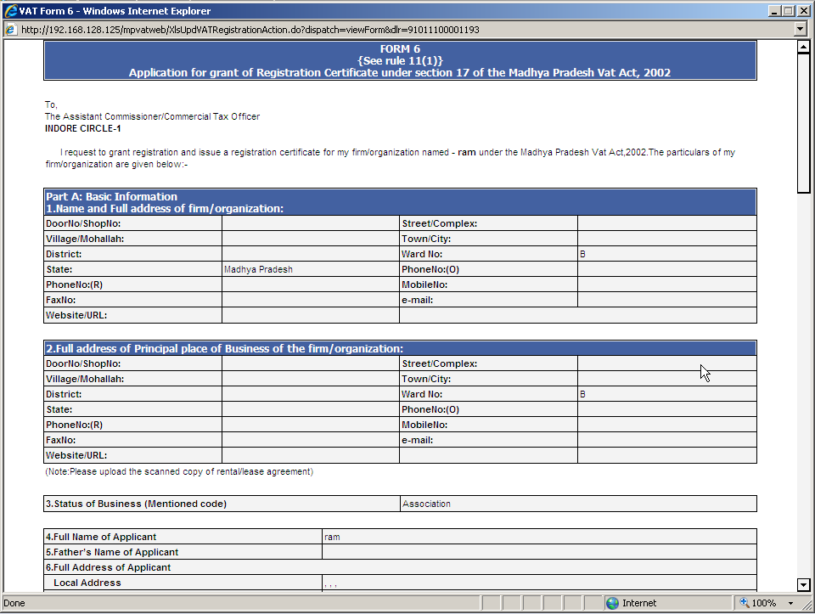

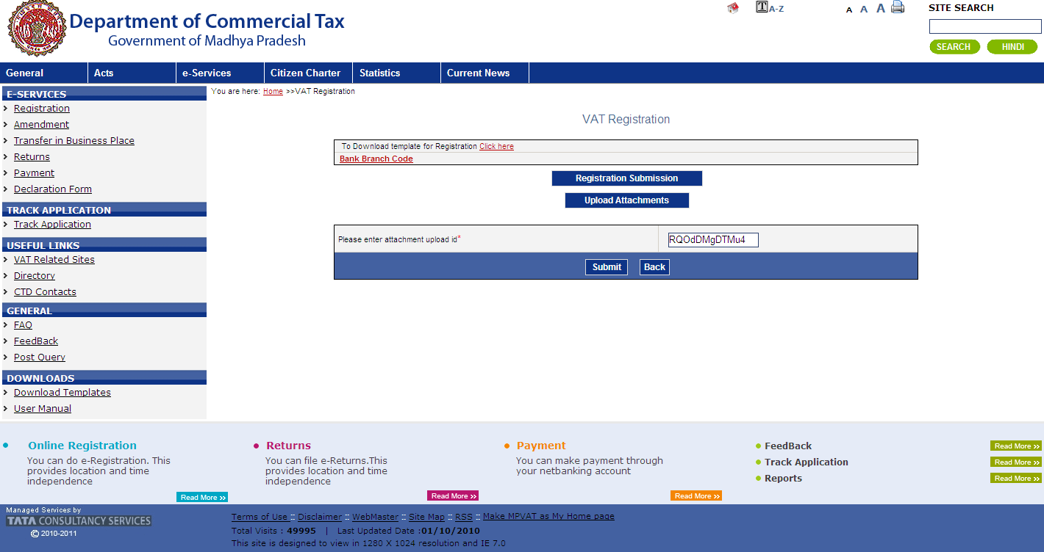

Enter transaction id and click on submit button.

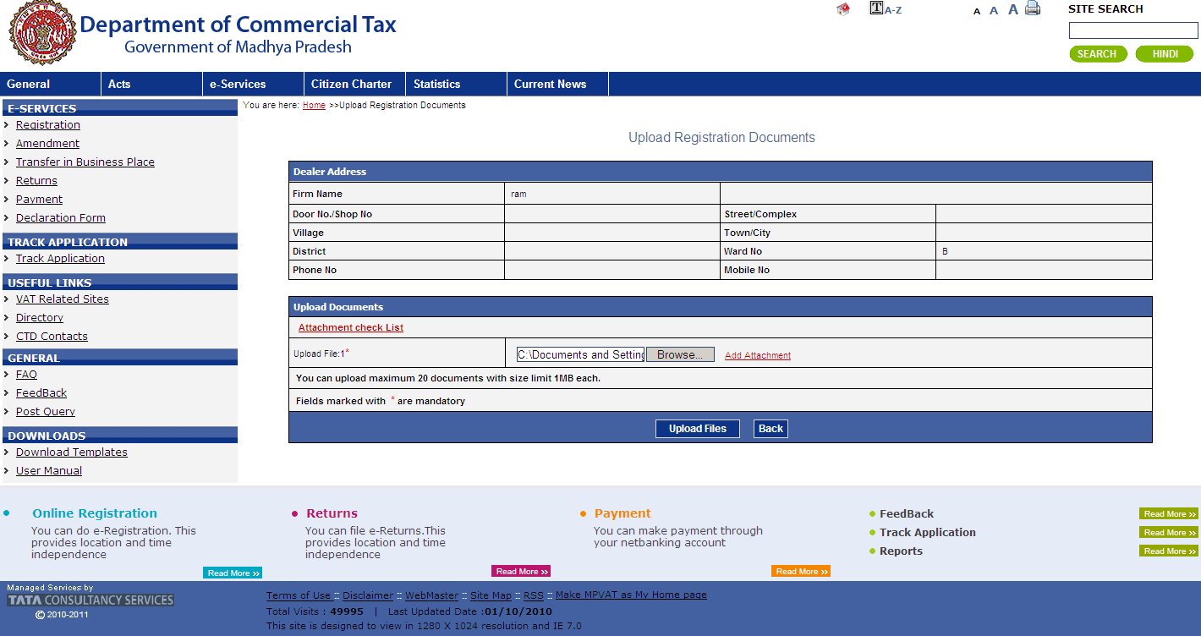
Upload the required document,after that click on upload files to get acknowledgement receipt.

3.1.5 Generation of Acknowledgement.

Click on Acknowledgement number to get Acknowledgement Receipt.

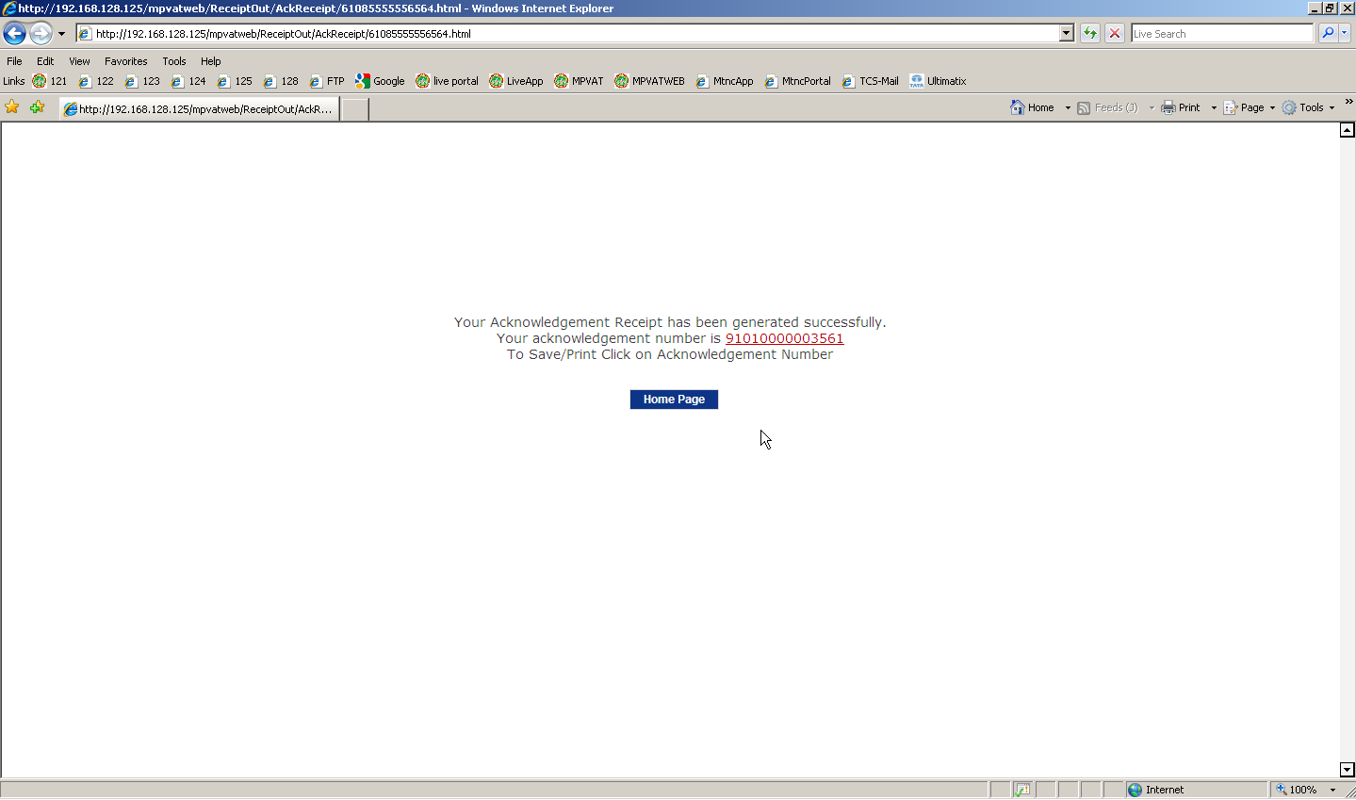

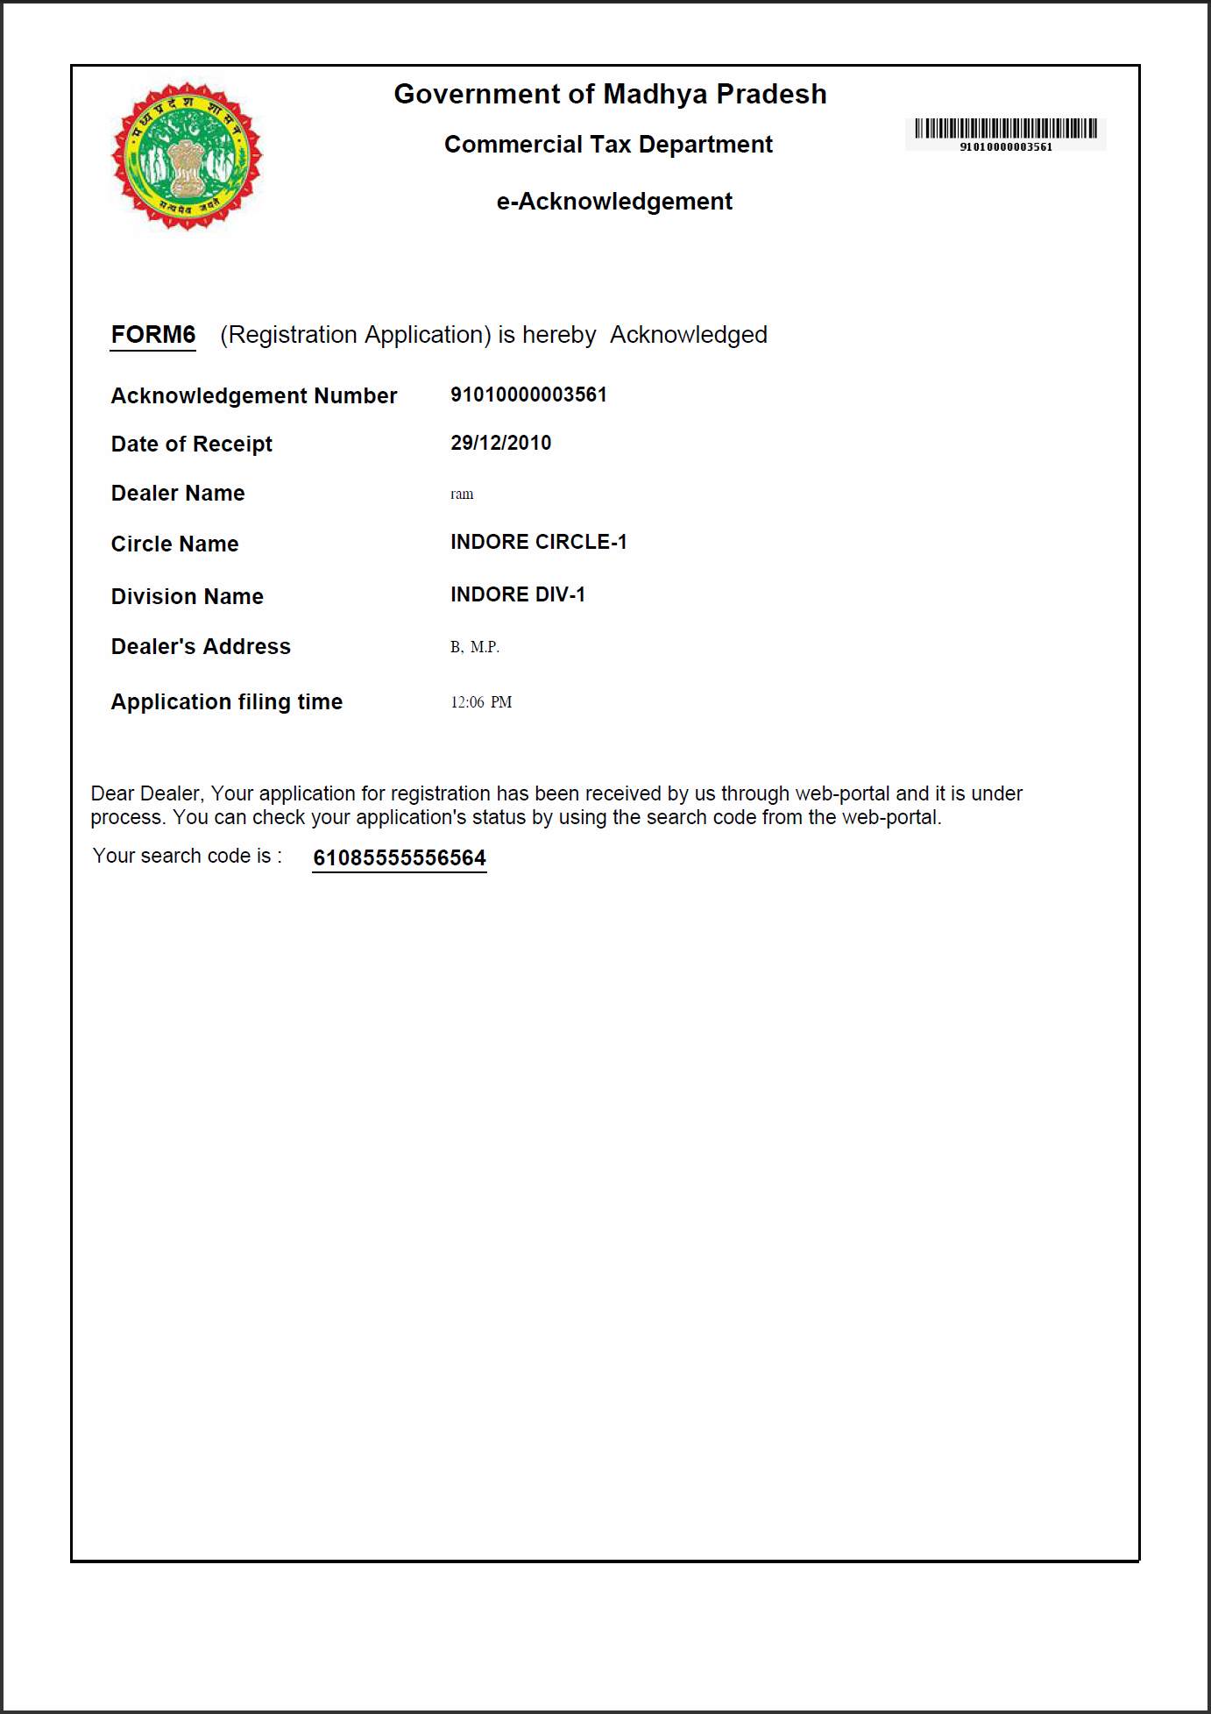

Important Points to be kept in mind:

- It is required to upload the same template that is downloaded from the web portal. Copy of any other template file will not be accepted.
- It is required to submit the physical form print, acknowledge receipt print out to the office in the stipulated time frame.

