Government of Madhya Pradesh

Madhya Pradesh VAT Portal

User Manual – e-Returns - VAT
Release 1.1

January, 2012

Government of Madhya Pradesh

Madhya Pradesh VAT Portal

User Manual – e-Returns - VAT
Version 1.1

January, 2012

Tata Consultancy Services Ltd
Info Tower I, Info city,
Airport Road
Gandhinagar-382009, Gujarat.

Notice
This is a controlled document. Unauthorized access, copying, replication or usage for a purpose other than for which it is intended, are prohibited.
All trademarks that appear in the document have been used for identification purposes only and belong to their respective companies.

PF3020
Document Release Note

Notice No.:
Customer: Commercial Taxes Department, Government of Madhya Pradesh
Project: MPVATIS
Document details
Name | Version no. | Description
TCS-MPVAT-UM-e-returns-VAT | Version 1.1 | The document is being prepared to assist the user to perform the process through the MPCTD Web-Portal of MPVATIS project. The document is prepared with the help of current version of application (Web-Portal module) and subject to minor/major change(s) due to the modification(s) in web portal, as and when applicable.

Revision details
Action taken  (add/del/change) | Previous  page no. | New page no. | Revision description

Change Register serial numbers covered:
The documents or revised pages are subject to document control.
Please keep them up-to-date using the release notices from the distributor of the document.
These are confidential documents. Unauthorized access or copying is prohibited.

Approved by: Authorized by:

Date: Date:

PF2060C
Document Revision List

Customer: Commercial Taxes Department, Government of Madhya Pradesh
Project: MPVATIS
Document Name: TCS-MPVAT-UM-e-returns-VAT

Release Notice Reference (for release)
Rev. No. | Revision date | Revision description | Page no. | Previous page no. | Action taken | Addenda/New page | Release notice reference

About this Manual

Purpose
The purpose of this document is to describe the e-Returns functionality in MPVAT Portal for VAT.

Intended Audience
This document is intended for the dealers in Madhya Pradesh.

Organisation of the Manual
Information in this manual has been organised as follows:

Table 1 : Organisation of Manual

Chapter | Description
Chapter 1 | It provides brief introduction of Web Portal.
Chapter 2 | This introduces e-returns procedure for the tax payer for VAT dealer

Contents
1 Introduction to web portal 11
2 E-Returns(VAT) 12
3 Operational Instruction 13
3.1.1 Log in 13
3.1.2 Preparation for the returns 17
3.1.3 Upload and Submit the form 18

List of Tables

Table 1 : Organisation of Manual 6
Table 2 : List of Abbreviations 10

List of Figures
Figure 1 : Home Page 14
Figure 2 : EPT dealer e-Returns Form 10 15
Figure 3 : Download Template 16
Figure 4 : Excel Sheet for e-Returns Form 10 for VAT Dealer 18
Figure 5 : Checking Form type 19
Figure 6 : Browse the Upload file. 20
Figure 7 : Entering Details for e-Returns Form for VAT dealer 21
Figure 8 : Data Validation 22
Figure 9 : No Error found screen 23
Figure 10 : Acknowledgement Receipt 24
Figure 11 : Track Your Status link in Home Page 25
Figure 12 : Track Your Status Screen with data entered 26
Figure 13 : Track Your Status Result after entering Search Code 27
Figure 14 : Track Your Status To Print status 28
Figure 15 : Screen to show return history link in right menu 29
Figure 16 : Search return application screen with filled data 30
Figure 17 : List of returns 31
Figure 18 : Detailed form view 35

List of Abbreviations

Table 2 : List of Abbreviations

Abbreviation/ Acronym | Description
TIN | Taxpayer Identification Number
URL | Uniform Resource Locator
UM | User Manual
CTD | Commercial Tax Department
FAQ | Frequently Asked Questions
RSS | Really Simple Syndication
VAT | Value Added Tax

- Introduction to web portal
The government of Madhya Pradesh has launched a web portal with URL https://www.mptax.mp.gov.in The web portal offers different kind of information on Commercial Taxes in Madhya Pradesh.
The portal offers major functionalities like:
- E-services like e-registration, e-returns, e-amendment, e-communication and e-payment
- News, updates, circulars and notifications
- ‘Search the website’ functionality
- Tracking the status of various applications on-line
- Using virtual keyboard for entering password
- FAQs, Query posting and replying
- Subscribe/view RSS feeds

- E-Returns(VAT)

Introduction

The Madhya Pradesh government has launched a website with URL https://www.mptax.mp.gov.in .The web portal offers different kind of information on VAT in Madhya Pradesh besides services to dealers including online return.

A dealer has to get registered on web portal to avail the facility of e- filing of return. This is a one-time activity.

Since e-filing is a new concept, this booklet has been prepared with a view to provide step-by-step guidance to the dealers in filing e-return. This booklet contains details and screen shots for e-filing the return in Form. E-filing of returns will save time for the dealer and the Department will be in a better position to quickly verify, analyze, assess and grant refund, if any.

NOTE:
In order to file e-Returns it is mandatory for the dealer to be registered on the website.

- Operational Instruction

Procedure to file e-return is very simple. A computer with internet connectivity is required for the
purpose. There are four easy steps to file e-return. These steps are

Step 1. Login.

Step 2. Preparation for the return.

Step 3. Uploading the return (.xls)

Step 4. Acknowledgement.

Step 5. Track Your Status

    - Log in

A dealer registered on the web site is required to Login for filing e-return. Process of log in is as under:

Connect to Internet and open the website https://www.mptax.mp.gov.in Home page.
Enter the login id and password in left side of the screen as shown below.

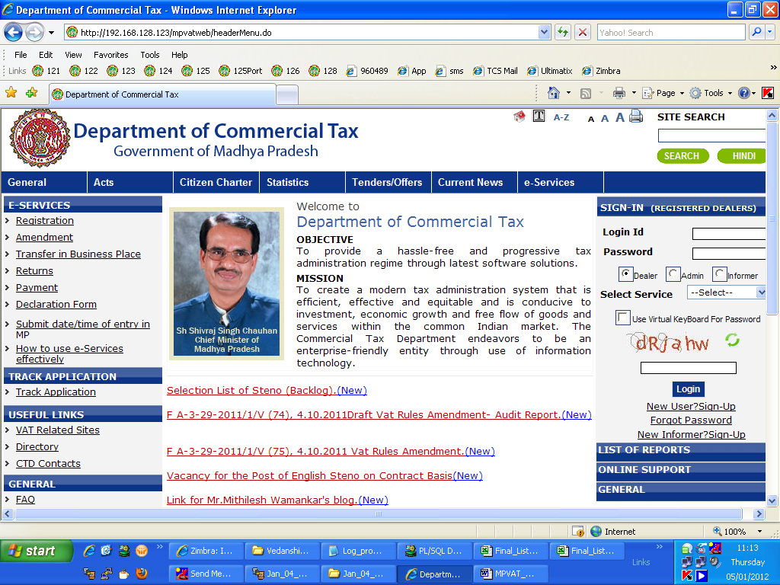
Click here

Figure 1 : Home Page

Please enter following details in the screen shown above:

Login id -- your TIN

Password -- Password that you have entered at the time of Sign-Up. (If you have not yet registered n the Website then just click on the Sign-Up button to register yourself).

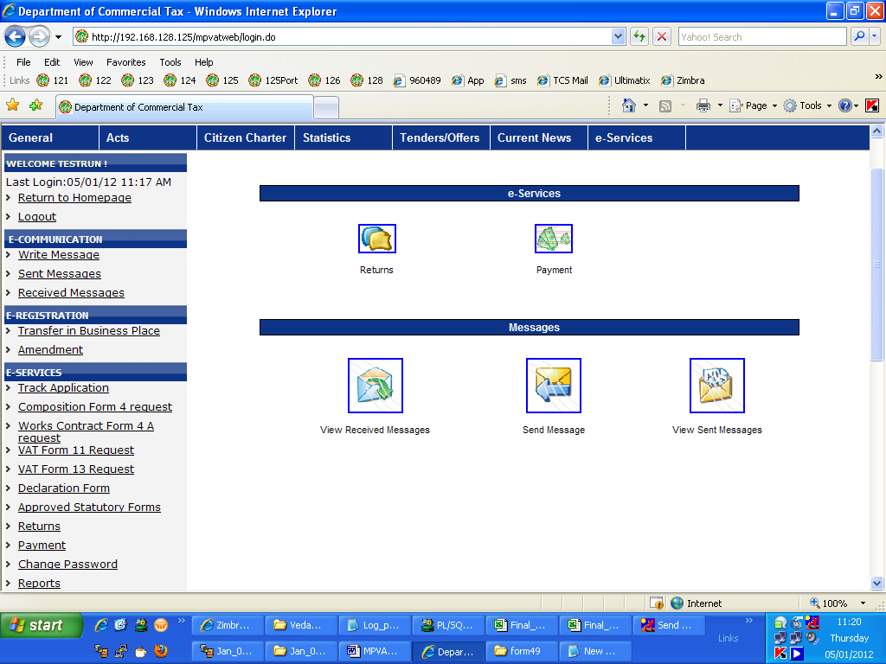
Figure 2 : VAT dealer e-Returns Form 10
Select VAT Returns Form 10

Select VAT Returns Form 10 from e-returns.
The following screen will appear.

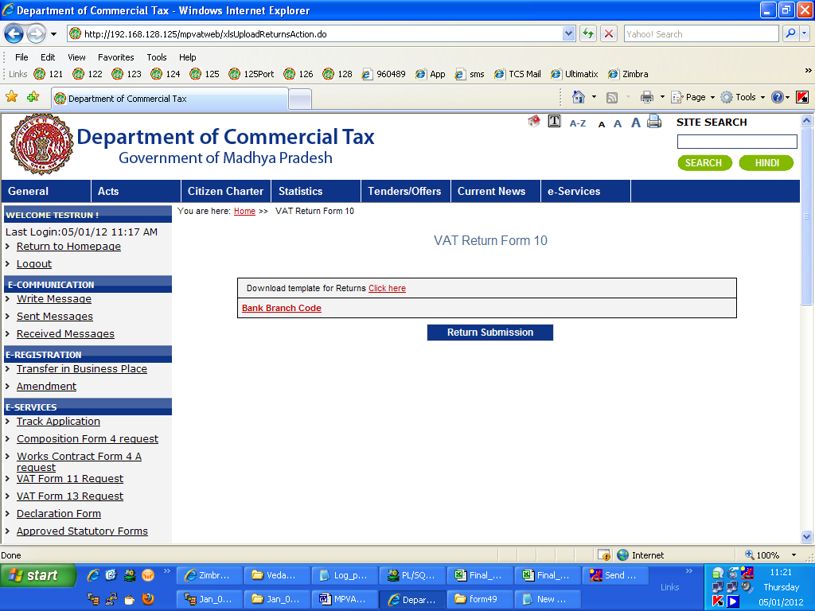
Click here to download the template

Figure 3 : Download Template

On clicking this link you will get the following form: VAT Returns Form10

Downloading necessary Templates:

To fill up the return, you are required to download the templates from the website. It is advisable to download the Latest templates from website.

To download the templates for filing e-Returns, just click on required form name (template)

3.1.2 Preparation for the returns
(Note: Please enable Macros in MS Excel as the sheet contains macros for various validations of data.)

After downloading requisite templates, data can be entered in these templates in following steps:

1). Download .xls file and save it in your local machine.

2). Open using Microsoft Excel and fill the required details.

3). After filling the sheet click on Validate button to validate the sheet.

4). If all the data is correct then it will prompt for generating the upload file.

5). The Upload file is saved in My Documents by default but you can browse and save as per your convenience.

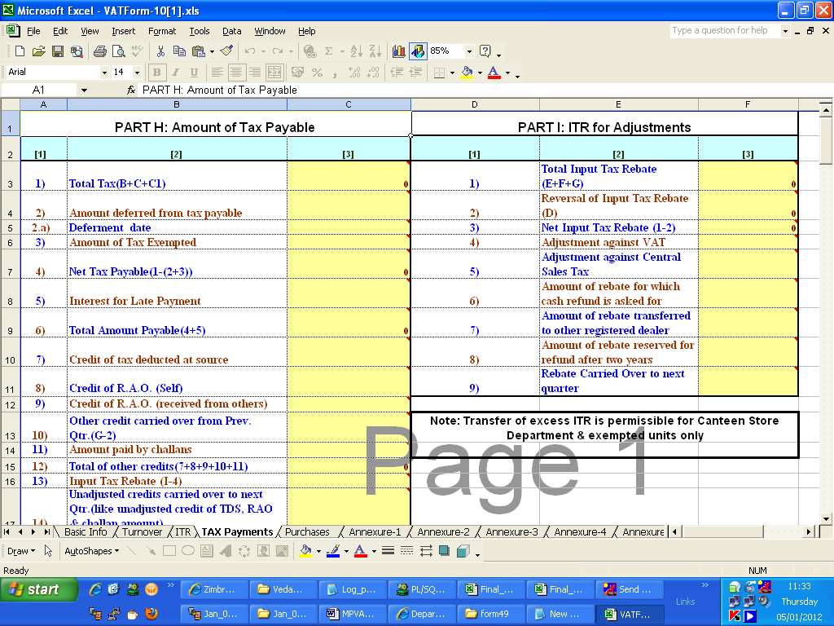

Figure 4 : Excel Sheet for e-Returns Form 10 for VAT Dealer

    - Upload and Submit the form

If after, downloading templates, if you had logged out of the system, please log-in again and to upload filled templates as described in following steps:

Go to the page where you had previously gone at the time of downloading the templates.

Note: Screens for downloading templates and uploading them on web site are the same.

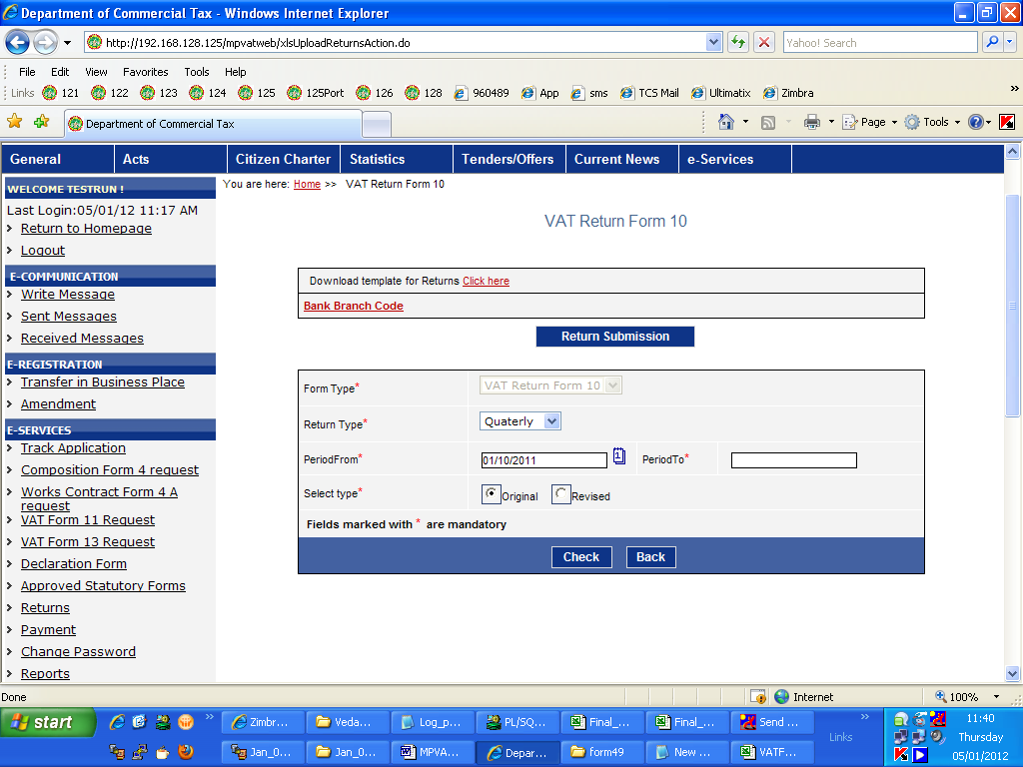

Figure 5 : Checking Form type

In the above screen select the return type (Monthly, Quarterly or Yearly), the return period and the Select type (Original: if filing return first time for given period else Revised).
Then click on Check button.
It will check whether the details given by the dealer are correct or not.

If all the details are correct then following screen will appear.

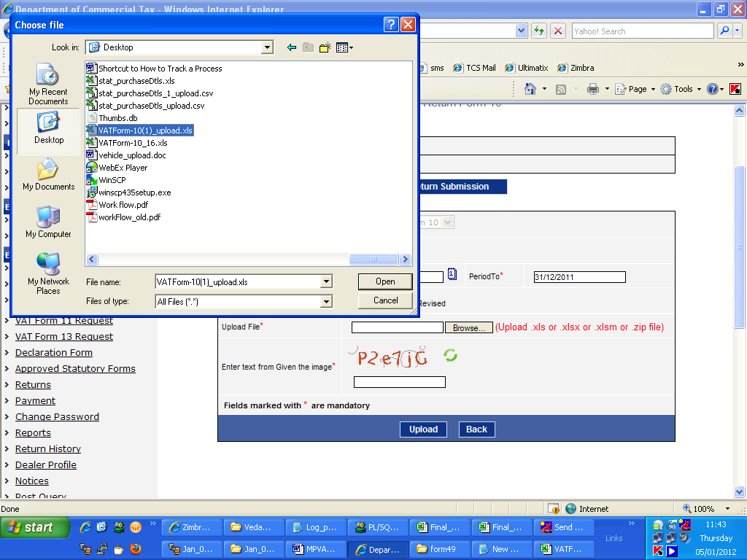

Figure 6 : Browse the Upload file.

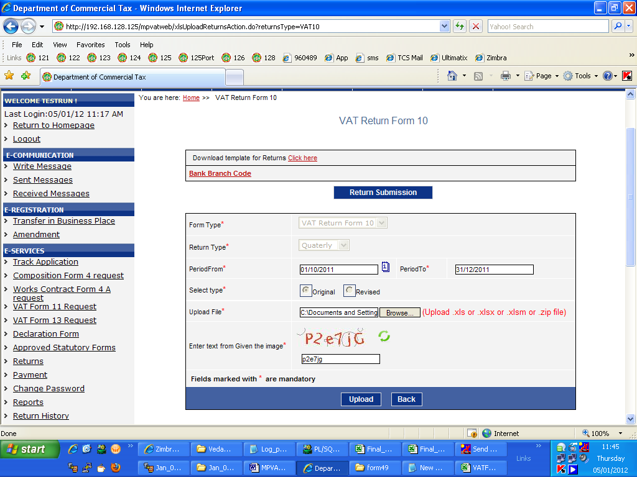

Figure 7 : Entering Details for e-Returns Form for VAT dealer

Click on browse button to locate the upload file.
Enter the text shown in image in the last text box.
And then click on upload button.
The following screen will appear showing the summary of upload.

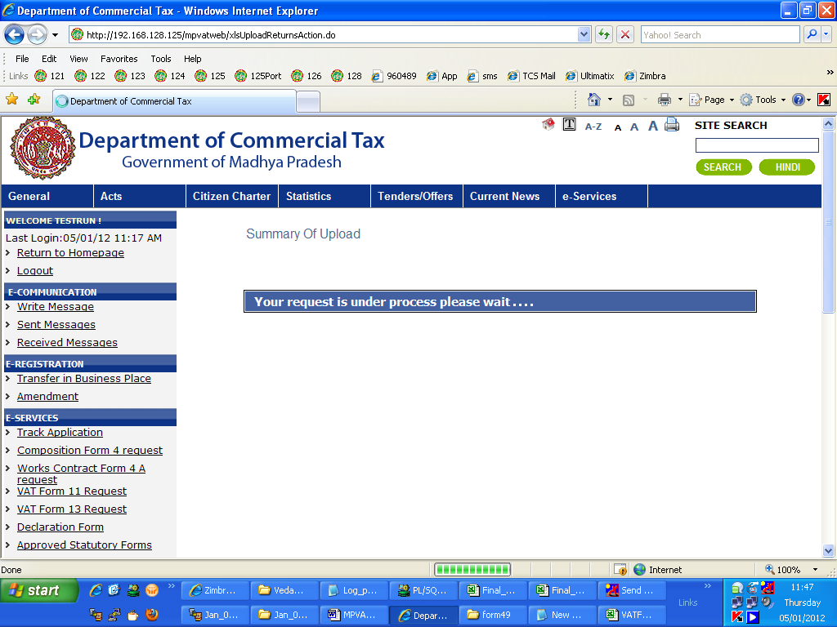

Figure 8 : Data Validation

Once all the data in upload file is validated, the following screen will appear.
If there is any error in the file it will show the error message. If there is no error then it will show
No Error found message as shown below.

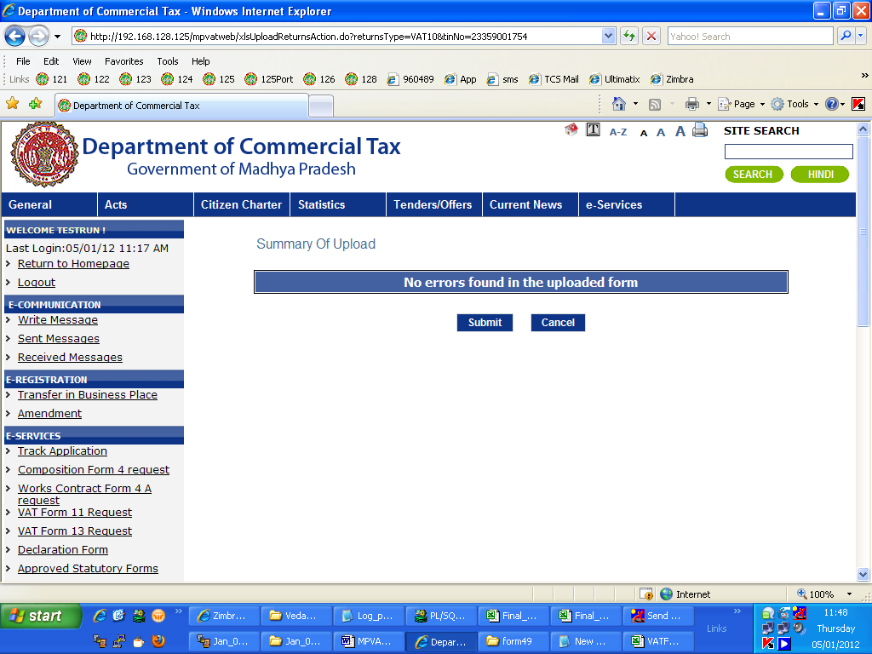

Figure 9 : No Error found screen

Now the dealer can click on Submit button to submit his returns file.

Generate the Acknowledgement Receipt:

After successfully submitting the form along with the attachments (if any), the acknowledgement receipt will be generated.

Once acknowledgement receipt is generated, you will not be allowed to file e-Returns for same period again.

Take a printout of generated acknowledgment receipt as shown below.

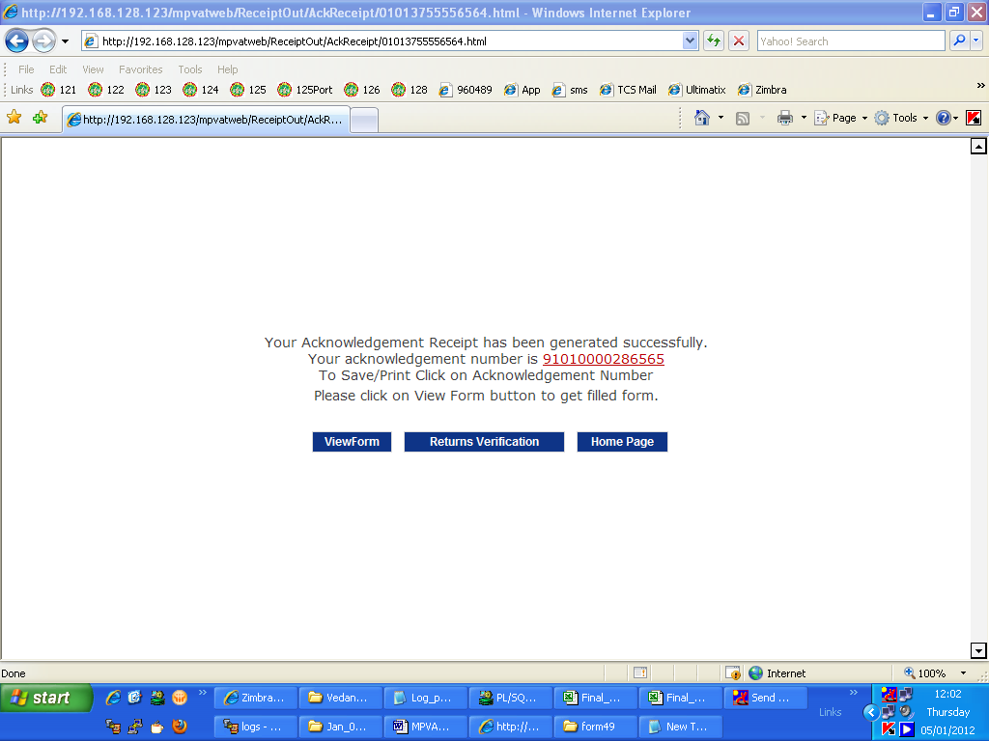

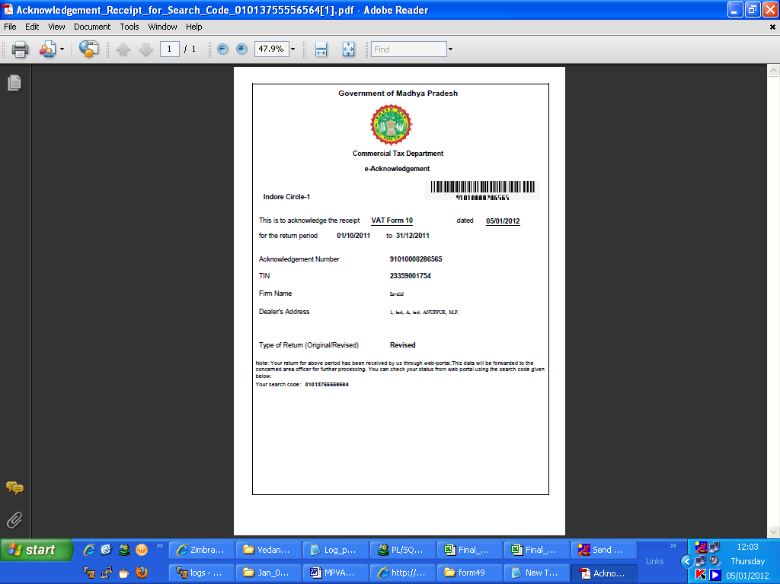

Figure 10 : Acknowledgement Receipt
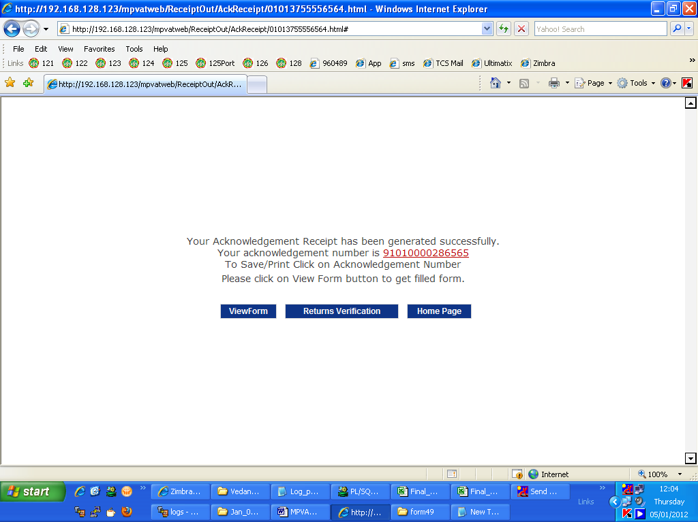

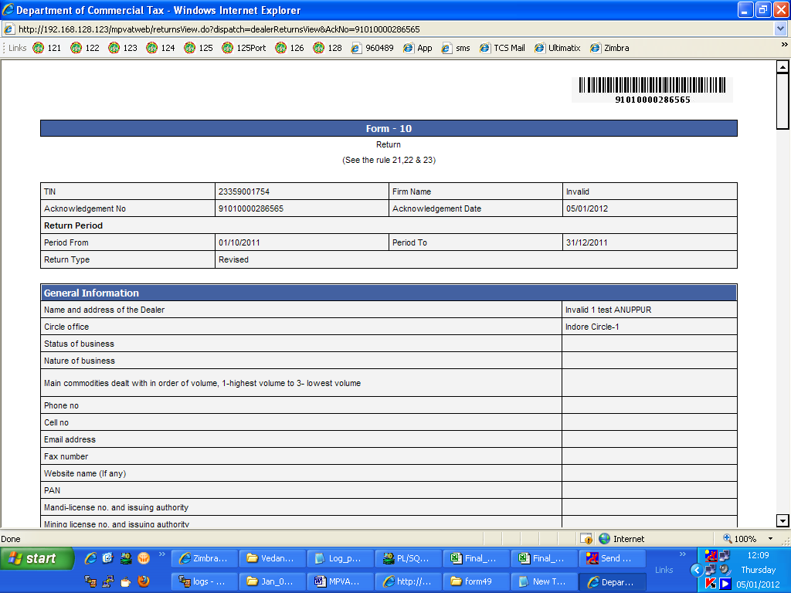
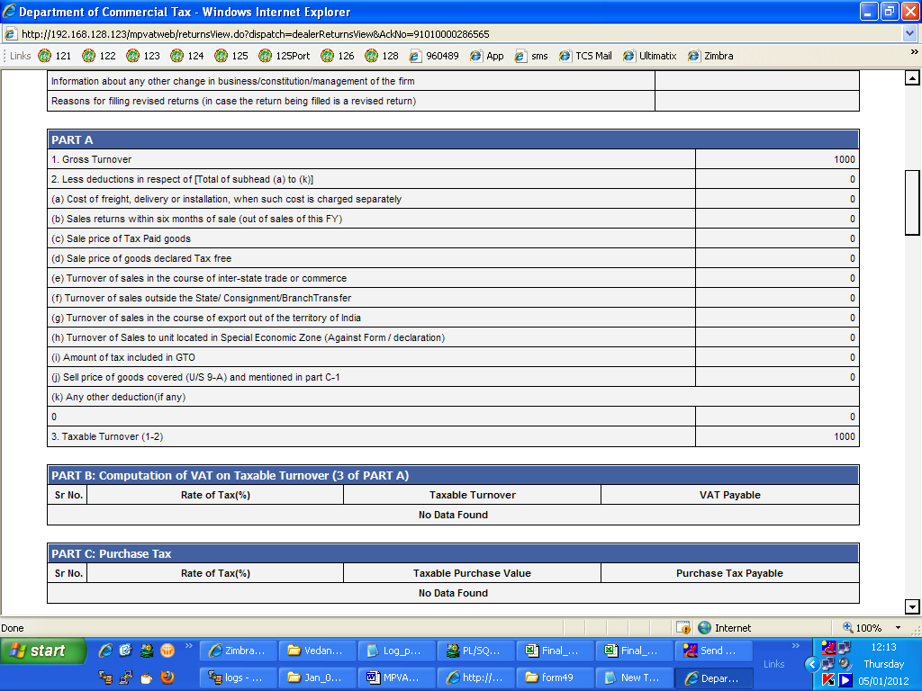

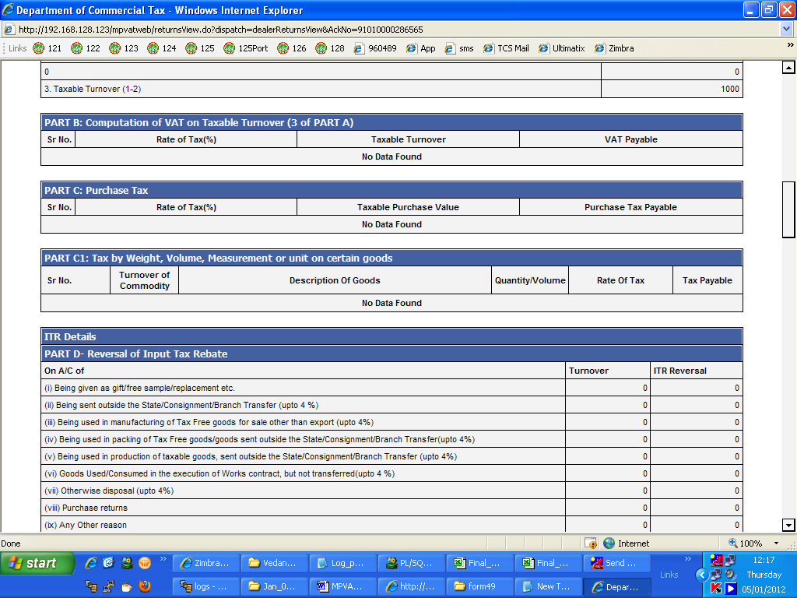
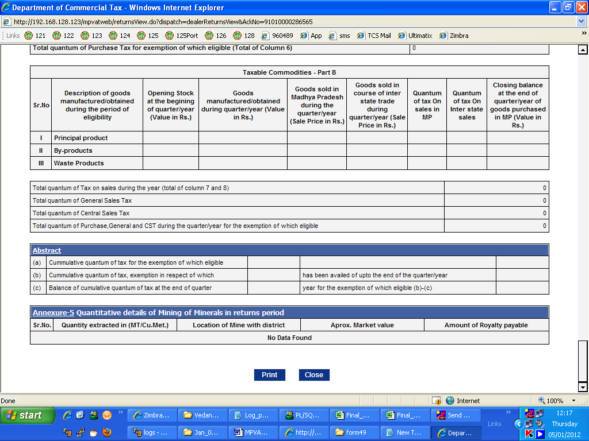

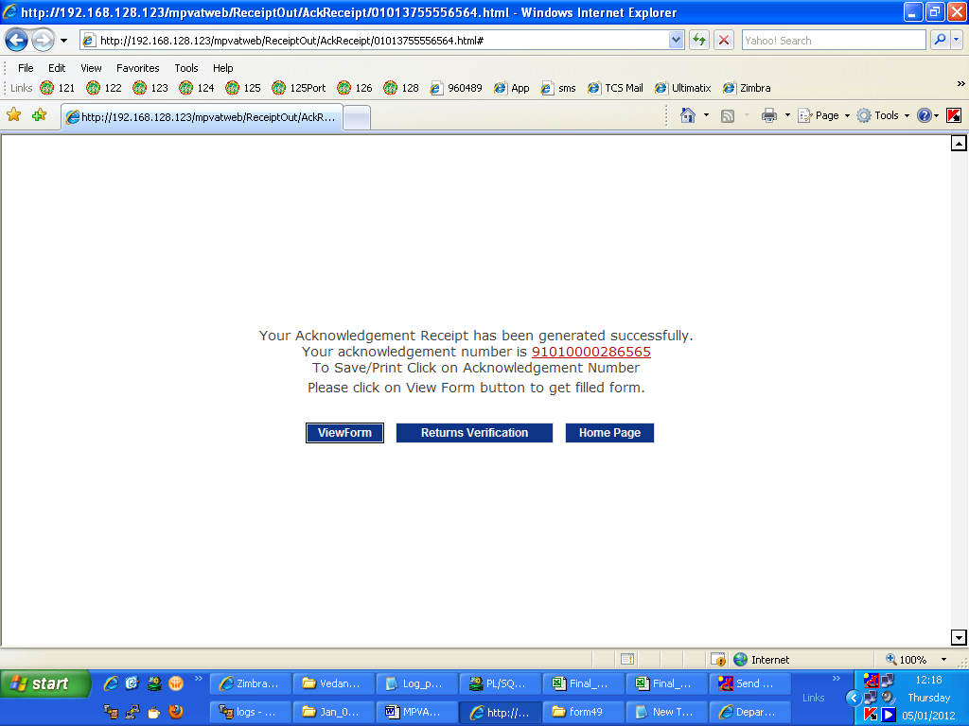
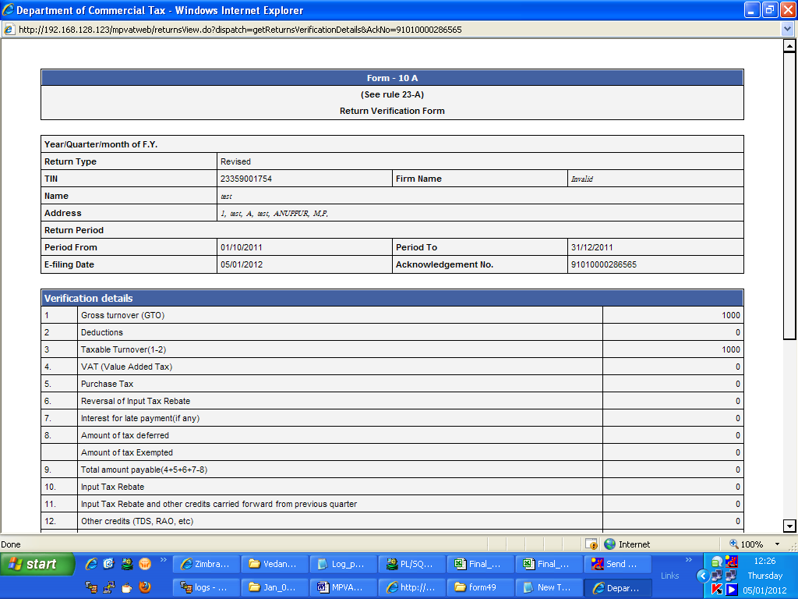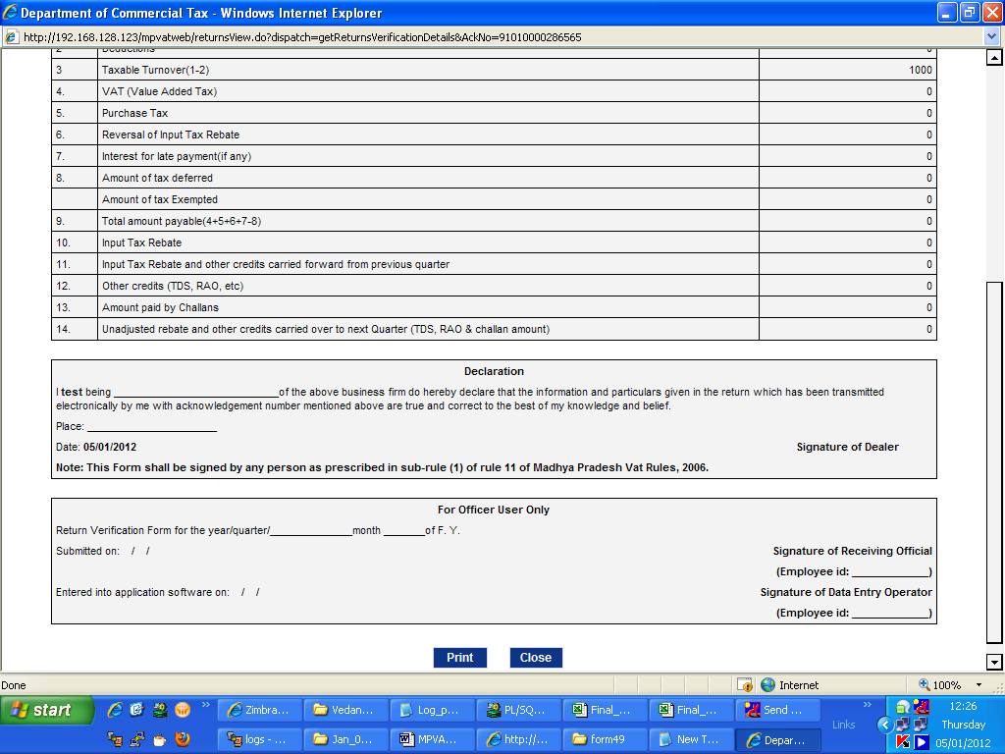
Track Your Status

Once the Acknowledgment receipt is generated, the dealer can track his status using acknowledgment number and search code.
Click on Home in top menu.
On Home Page click on Track Your Status link as shown below.

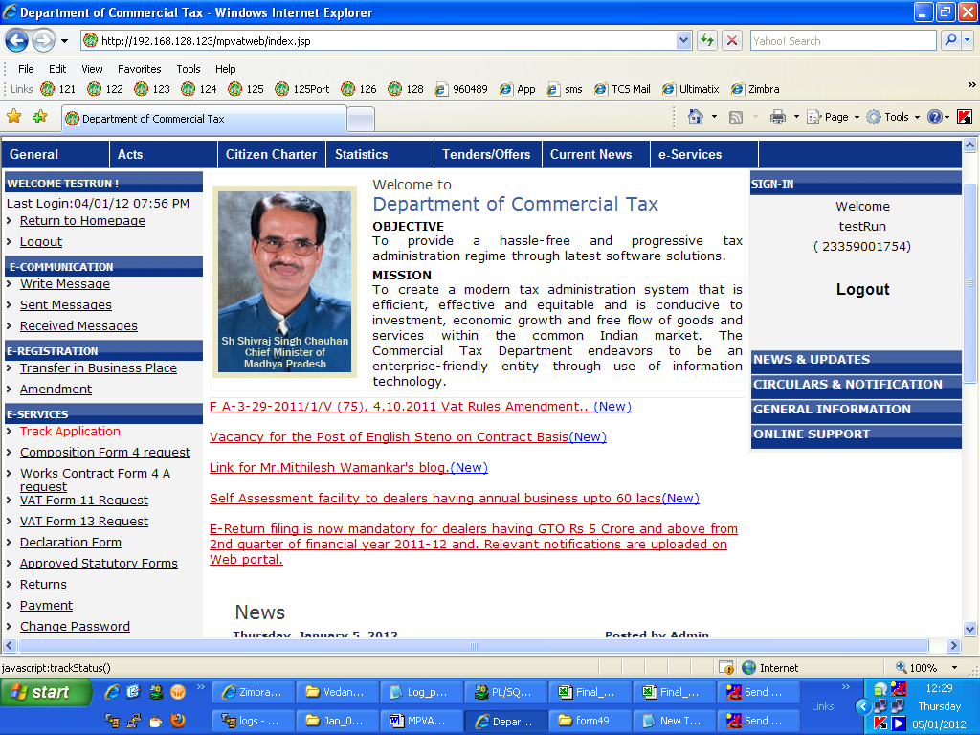
Click on Track Application

Figure 11 : Track Your Status link in Home Page

After clicking on above link, following screen will appear.

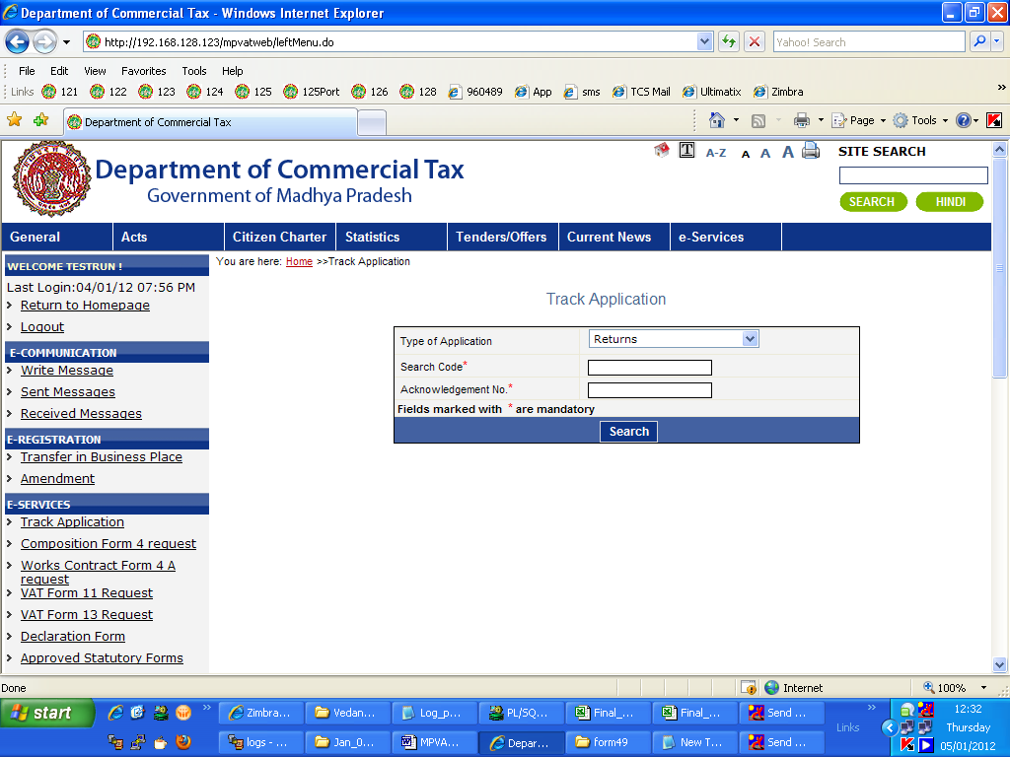

Figure 12 : Track Your Status Screen with data entered

Select e-Return in Type of application.
Enter search code and acknowledgment no. in above fields and click on search button.
Following screen will appear showing the status of your e-returns.

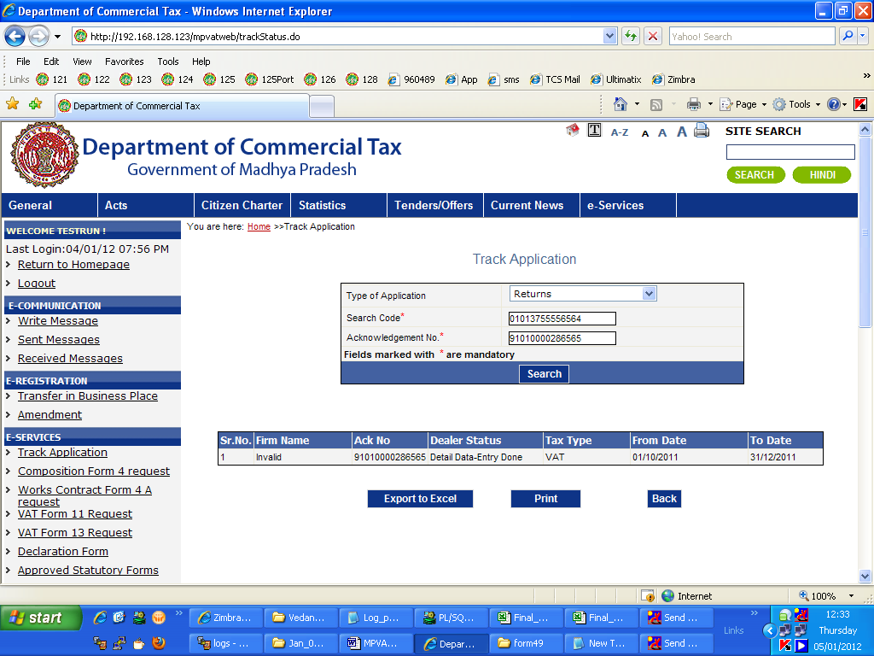

Figure 13 : Track Your Status Result after entering Search Code

Click on Export to excel link if you want to export the details to excel.

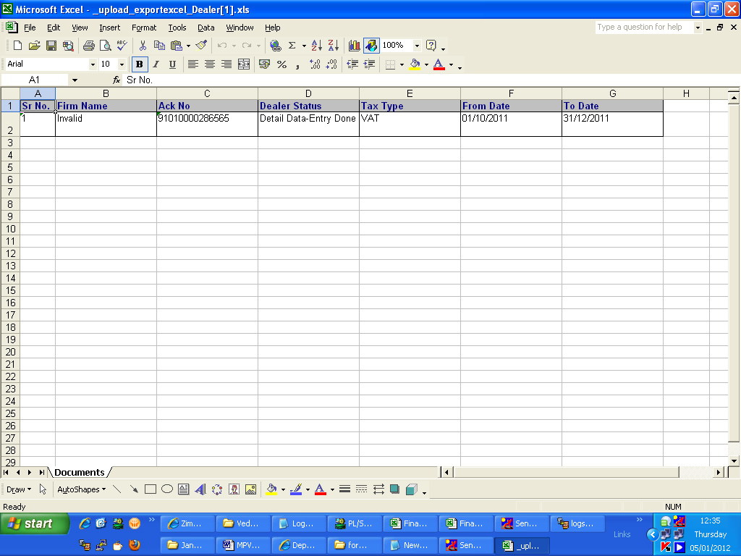
Figure 14 : Track Your Status To Print status
Return History

The dealer can view the details of the returns filed by him for any period in Return history link in right menu on Home Page.

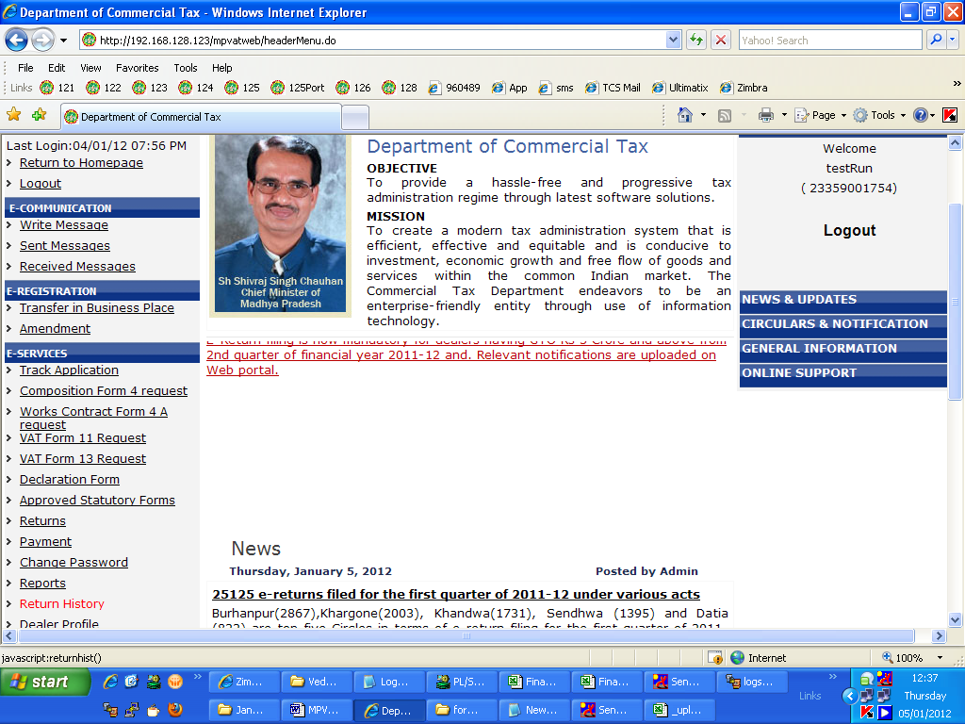

Figure 15 : Screen to show return history link in right menu

Click on Return History link in right menu. Enter the required fields in search return application page and click on search.

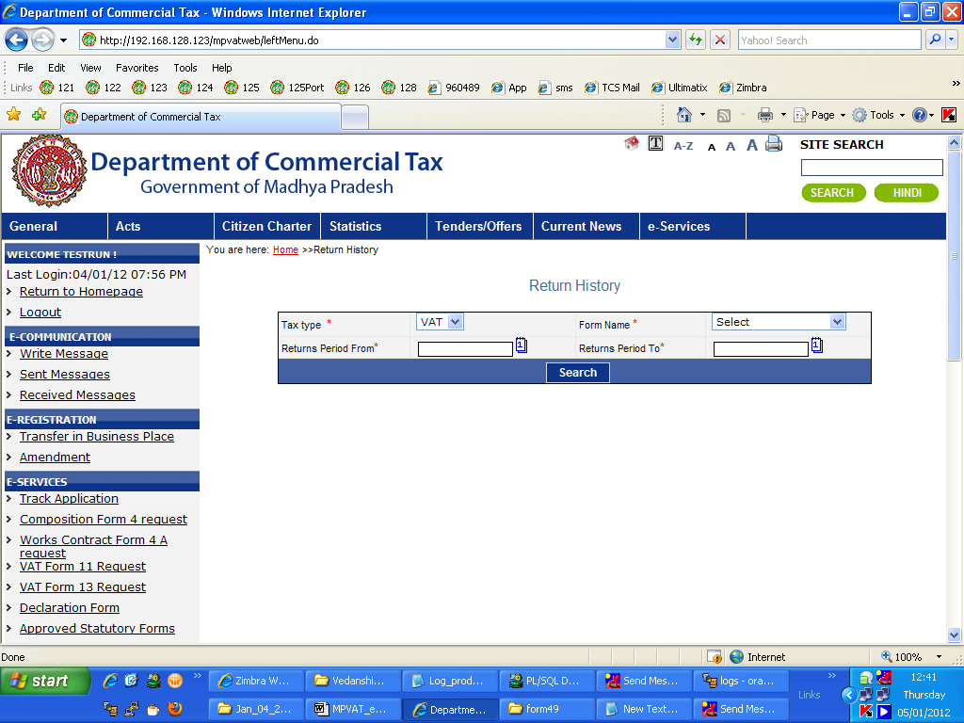

Figure 16 : Search return application screen with filled data

After clicking on search following screen will appear showing a list of returns filed by the dealer.

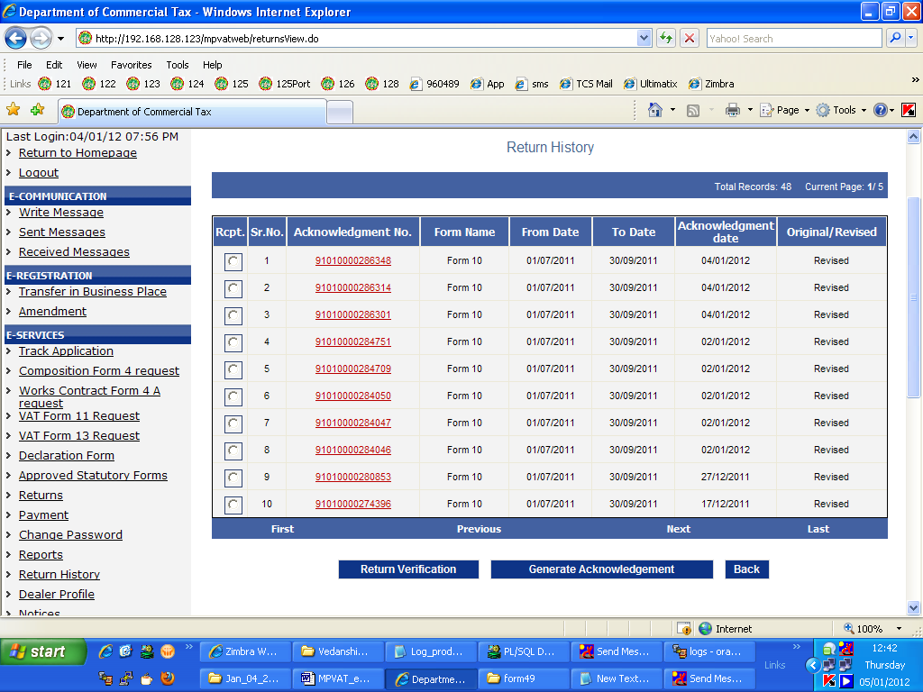
Figure 17 : List of returns

Now click on any Acknowledgment no to view the form.

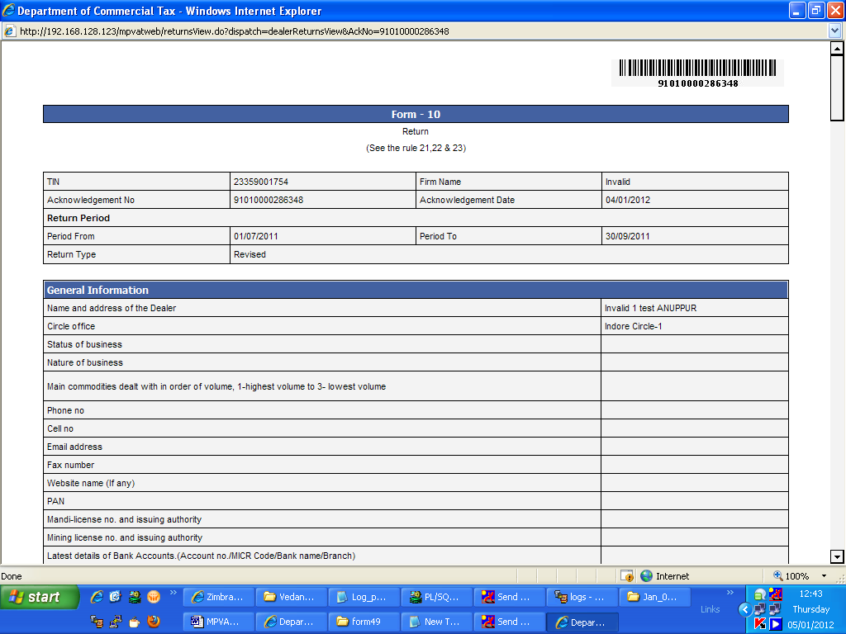

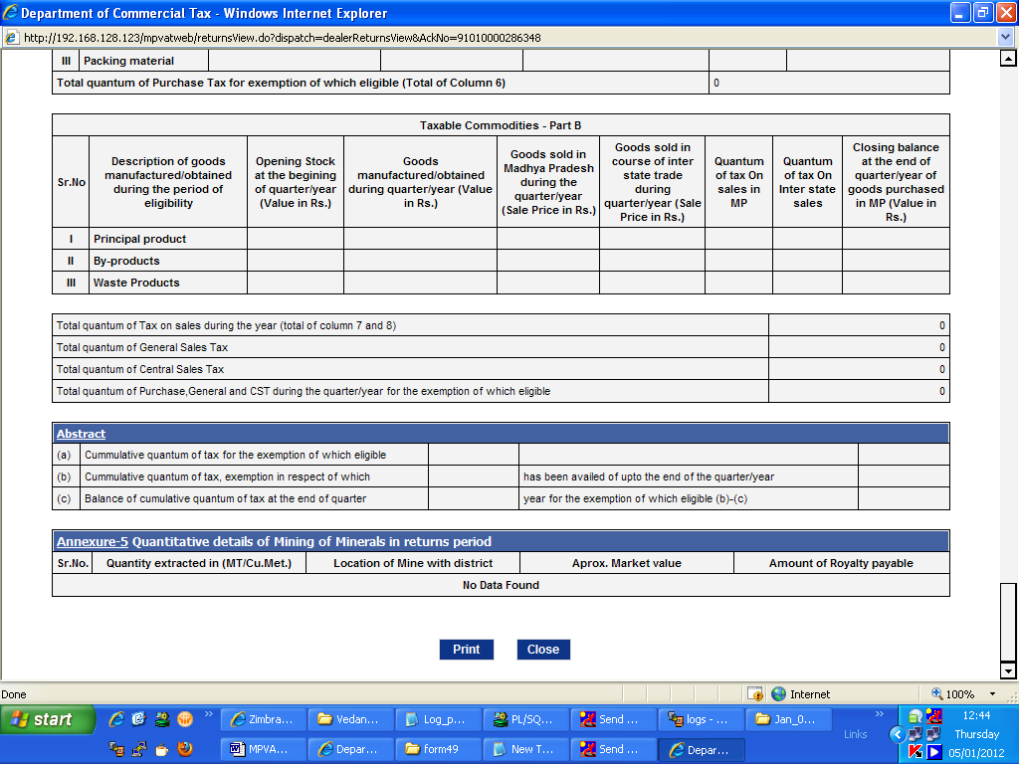

Figure 18 : Detailed form view
Click on Print button to print the form.

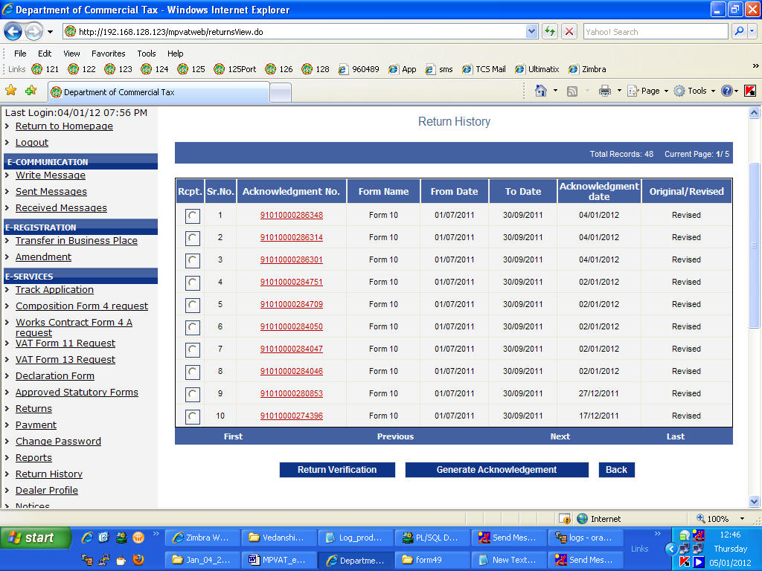

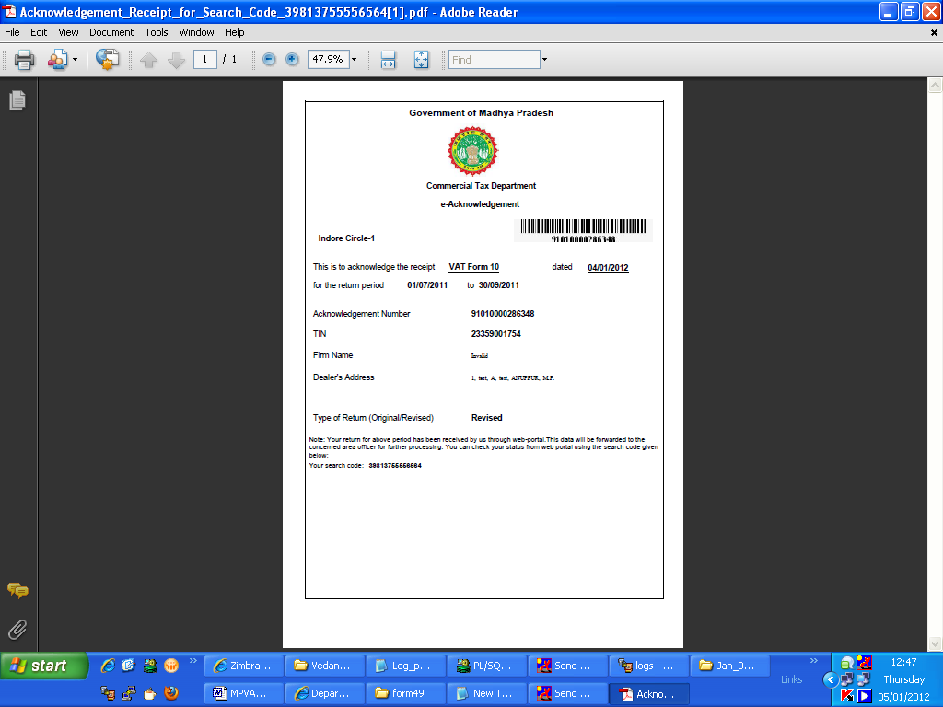

Important Points to be kept in mind:
1. Dealer can not file return for the present incomplete month and future month. He can only
file return for his previous months.
2. It is required to upload the same template that is downloaded from the website. Copy of
any other template file will not be accepted.
3. Quarter means period of three months ending on 30th June, 30th September, 31st
December and 31st March.
4. Please do not share the password with anybody.

